

**ST LEONARDS**

**PRIMARY SCHOOL P** (03) 9384 2204

**M** 0403 149 391

** E** [mitch@kellysports.com.au](mailto:mitch@kellysports.com.au)

**SUPER SOCCER**

Come and experience all the fun in our 9 week Kelly Sports

Super Soccer Sports program  
Learn how to play like your heroes and have lots of fun learning all the skills in the game of SOCCER. The Kelly Sports team will teach you all the basic skills in a safe and challenging environment. If you already play soccer this is your chance to take your game to the next level!

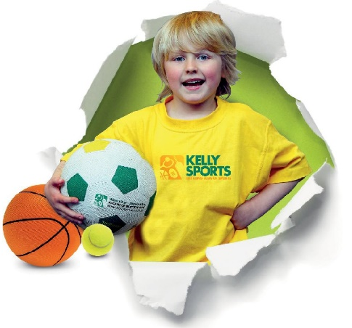



**How To Enrol?**Please visit [www.kellysports.com.au/events](http://www.kellysports.com.au/events) and search for your school.  
Our new booking system requires upfront payments to secure your position. For more information, please call the head office.



**"The Kelly Sports Programs offer our students opportunities for physical activities; including dance & multi-sports. Conveniently located on our school grounds, they are popular with students and their families. Staff are skilled in working with young people to love active participation.”**



***Amanda Hay, Principal – Newtown Primary School***

**CLASS INFORMATION**

Only 14 spots available so sign up fast to secure your position  
  
Skills include **Passing, dribbling, shooting** andwe will incorporate our Kelly Sports Modified games children love

Come & join us every Monday straight after school.

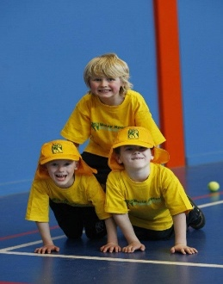

**When: Monday**  
**Starts: 23th July**  
**Finishes: 17th September**  
**Time: 3:20pm – 4:20pm**  
**Year Levels: Prep – 4  
Cost: $118.80 (Inc GST)**

