

**OLMC**

**PRIMARY SCHOOL P** (03) 9384 2204

**M** 0403 149 391

** E** [mitch@kellysports.com.au](mailto:mitch@kellysports.com.au)

**STREET DANCE**

Breaking, Popping and Locking! Our Dance coaches can get your child’s hips swinging, feet rocking and heads bumping to the original street dancing. Street dance is a FUSION of styles that your child can enjoy dancing out to. Sign up fast as places are limited for our program and let our coaches beat, ignite your child’s feet!

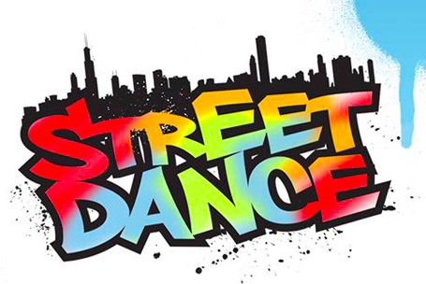



**ONLINE ENROLMENT www.kellysports.com.au**

To enrol, please visit [**www.kellysports.com.au**](http://www.kellysports.com.au)**, and search for your  
school.** Our booking system requires credit card upfront payments to   
secure your position. For more information, please call the head office**.**





**CLASS INFORMATION**

Only 14 spots available for each program so sign up fast to secure your position  
  
 At the end of the term, Parents will be invited to our last class for a performance of the routine the kids have been working on.

Sign up anytime and only pay for the remaining weeks in the term - $13.20 per week

**When: Tuesday’s**  
**Starts: 23rd July**  
**Finishes: 17th September**   
**Time: 1.20pm – 2pm**  
**Year Levels: Prep – 4  
Cost: $118.80 Inc GST**



**"The Kelly Sports Programs offer our students opportunities for physical activities; including dance & multi-sports. Conveniently located on our school grounds, they are popular with students and their families. Staff are skilled in working with young people to love active participation.”**

***Amanda Hay, Principal – Newtown Primary School***

