

P.O. Box 71, Moonee Vale 3055
T (03) 9384 2204
FOLLOW US
ONLINE

F (03) 9384 2205

E mitch@kellysports.com.au





WOODEND PRIMARY SCHOOL
SIZZLING SUMMER SPORTS

WHEN: Thursday
COMMENCING: 12/02/15
CONCLUDING: 26/03/15
TIME: 3.40pm – 4.40pm
YEAR LEVELS: P – 4
COST: $70

Kelly Sports is back in Term 1 for a SIZZLING SUMMER OF SPORTS!! Over 7 weeks your child will participate in range of lively and energetic programs including Cricket, Basketball, and Soccer. This program will not only improve key sporting skills but also increase crucial motor skills, all in a fun, friendly and exciting environment. Enrol them now and let Kelly Sports give them a Life Long Love of Sports.


TERRIFIC TENNIS


WHEN: Thursday
COMMENCING: 12/02/15
CONCLUDING: 26/03/15
TIME: 1.00pm – 1.50pm
YEAR LEVELS: P – 4
COST: $70

BE THE NEXT TENNIS SENSATION! Our Tennis program will ensure your child will develop new skills, build coordination and awareness and increase their confidence. As well as allowing your child to play and learn how to play fairly and have fun all in an enjoyable environment

GET IN QUICK FOR TERM 1 AS PLACES FILLING FAST
It’s here online enrolments !
To enrol, please visit www.kellysports.com.au or
fill out the enrolment form & send with a cheque or credit card details to:
Kelly Sports PO BOX 71, Moonee Vale, VIC, 3055.
Payment options available!
Do not leave enrolment forms at the school office

$70 FOR 7 WEEK PROGRAM
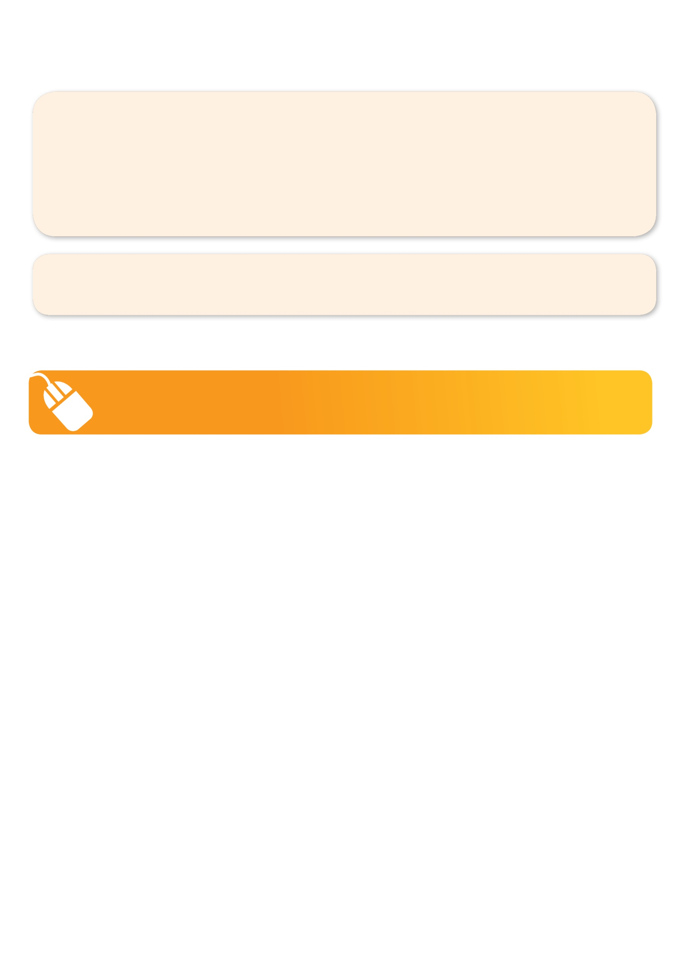
It’s here online enrolments !
To enrol, please visit www.kellysports.com.au or
fill out the enrolment form & send with a cheque or credit card details to:
Kelly Sports PO BOX 71, Moonee Vale, VIC, 3055.
Payment options available!
Do not leave enrolment forms at the school office

NEW IMPROVED ONLINE BOOKING SYSTEM!!!
SIMPLY GO TO WWW.KELLYSPORTS.COM.AU ENTER YOUR POST CODE AND ENROL FROM THERE. OR
FILL OUT THE BELOW ENROLMENT FOR & SEND WITH A CHEQUE OR CREDIT CARDS DETAILS TO:
PO BOX 71, MOONEE VALE, 3055
PAYMENT OPTIONS AVALIABLE!

It’s here online enrolments !
To enrol, please visit www.kellysports.com.au or
fill out the enrolment form & send with a cheque or credit card details to:
Kelly Sports PO BOX 71, Moonee Vale, VIC, 3055.
Payment options available!
Do not leave enrolment forms at the school office

It’s here online enrolments !
To enrol, please visit www.kellysports.com.au or
fill out the enrolment form & send with a cheque or credit card details to:
Kelly Sports PO BOX 71, Moonee Vale, VIC, 3055.
Payment options available!
Do not leave enrolment forms at the school office

It’s here online enrolments !
To enrol, please visit www.kellysports.com.au or
fill out the enrolment form & send with a cheque or credit card details to:
Kelly Sports PO BOX 71, Moonee Vale, VIC, 3055.
Payment options available!
Do not leave enrolment forms at the school office

ENROLMENT FORM
 Sizzling Summer Sports  Tennis
School: Year Level:
Name: Room No:
Address: Post Code:
Phone: Mobile/Work:
Email: Medical Conditions:

At the completion of after school clinics, does your child?  Go to after care  Get collected
Parents’ consent: I hereby authorise Kelly Sports to act on my behalf should my child require medical attention, and release
Kelly Sports North West from any liability for injury incurred by my child at Kelly Sports programs.
Parent/Caregiver name: Signature:
Amount Paid: $ Credit card payment:  Visa  Master card
Card Number:    Expiry Date: /CVV:
THINGS TO KNOW
Kelly Sports is a Registered Child Care provider
Don’t leave forms at the School Office
Spaces are limited so please make sure you enrol online or return form to Kelly Sports.

