

P.O. Box 71, Moonee Vale 3055
T (03) 9384 2204
FOLLOW US
ONLINE

F (03) 9384 2205

E mitch@kellysports.com.au





WESLEY COLLEGE

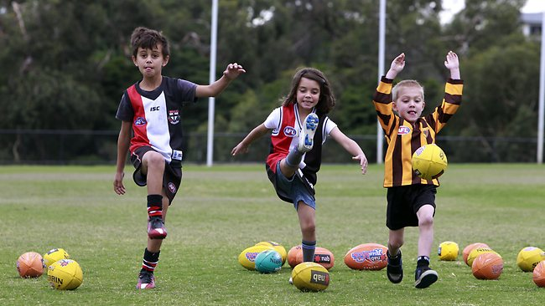
AFL

WHEN: Thursday
COMMENCING: 12/02/15
CONCLUDING: 26/03/15
TIME: 3.45pm – 4.45pm
YEAR LEVELS: P – 4
COST: $70
The Kelly Sports AFL program gives your child a fun and safe Australian Football experience. Over 7 weeks your child will participate in a range of drills and activities aimed to improve basic skills all in an exciting and fast paced environment. The program is not only about introducing children to AFL but also aims to improve confidence and social skills. Sign up now with friends!!



GET IN QUICK FOR TERM 1 AS PLACES FILLING FAST
It’s here online enrolments !
To enrol, please visit www.kellysports.com.au or
fill out the enrolment form & send with a cheque or credit card details to:
Kelly Sports PO BOX 71, Moonee Vale, VIC, 3055.
Payment options available!
Do not leave enrolment forms at the school office

$70 FOR 7 WEEK PROGRAM
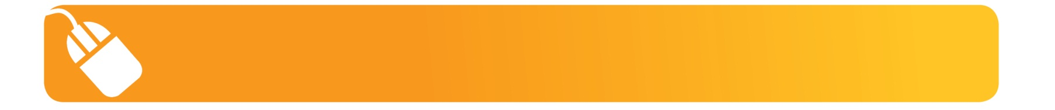
It’s here online enrolments !
To enrol, please visit www.kellysports.com.au or
fill out the enrolment form & send with a cheque or credit card details to:
Kelly Sports PO BOX 71, Moonee Vale, VIC, 3055.
Payment options available!
Do not leave enrolment forms at the school office

ONLINE BOOKING SYSTEM!!!
SIMPLY GO TO WWW.KELLYSPORTS.COM.AU ENTER YOUR POST CODE AND ENROL FROM THERE. OR
FILL OUT THE BELOW ENROLMENT FOR & SEND WITH A CHEQUE OR CREDIT CARDS DETAILS TO:
PO BOX 71, MOONEE VALE, 3055
PAYMENT OPTIONS AVALIABLE!

It’s here online enrolments !
To enrol, please visit www.kellysports.com.au or
fill out the enrolment form & send with a cheque or credit card details to:
Kelly Sports PO BOX 71, Moonee Vale, VIC, 3055.
Payment options available!
Do not leave enrolment forms at the school office

It’s here online enrolments !
To enrol, please visit www.kellysports.com.au or
fill out the enrolment form & send with a cheque or credit card details to:
Kelly Sports PO BOX 71, Moonee Vale, VIC, 3055.
Payment options available!
Do not leave enrolment forms at the school office

It’s here online enrolments !
To enrol, please visit www.kellysports.com.au or
fill out the enrolment form & send with a cheque or credit card details to:
Kelly Sports PO BOX 71, Moonee Vale, VIC, 3055.
Payment options available!
Do not leave enrolment forms at the school office

ENROLMENT FORM
 AFL
School: Wesley College Year Level:
Name: Room No:
Address: Post Code:
Phone: Mobile/Work:
Email: Medical Conditions:

At the completion of after school clinics, does your child?  Go to after care  Get collected
Parents’ consent: I hereby authorise Kelly Sports to act on my behalf should my child require medical attention, and release
Kelly Sports Blackburn from any liability for injury incurred by my child at Kelly Sports programs.
Parent/Caregiver name: Signature:
Amount Paid: $ Credit card payment:  Visa  Master card
Card Number:    Expiry Date: /CVV:
THINGS TO KNOW
Kelly Sports is a Registered Child Care provider
Don’t leave forms at the School Office
Spaces are limited so please make sure you enrol online or return form to Kelly Sports.

