

P.O. Box 71, Moonee Vale 3055
T (03) 9384 2204
F (03) 9384 2205
HURRY
PLACES
LIMITED

E lukebyles@kellysports.com.au


THE KNOX SCHOOL


WACKY WINTER SPORTS

FOOTBALL - SOCCER - DODGEBALL – TURBO TOUCH
This programme is a great way to challenge and improve your child’s motor skills and coordination within a FUN environment. We aim to develop and enhance ball skills, catching, kicking, throwing, co-operative skills and teamwork while improving strength, flexibility, hand-eye co-ordination and spatial awareness.

WHEN: Monday
COMMENCING: 14/7/14
CONCLUDING: 8/9/14
TIME: 3.30pm – 4.30pm
YEAR LEVELS: P – 4

COST: $90
It’s here online enrolments !
To enrol, please visit www.kellysports.com.au or
fill out the enrolment form & send with a cheque or credit card details to:
Kelly Sports PO BOX 71, Moonee Vale, VIC, 3055.
Payment options available!
Do not leave enrolment forms at the school office

VENUE: The Knox School
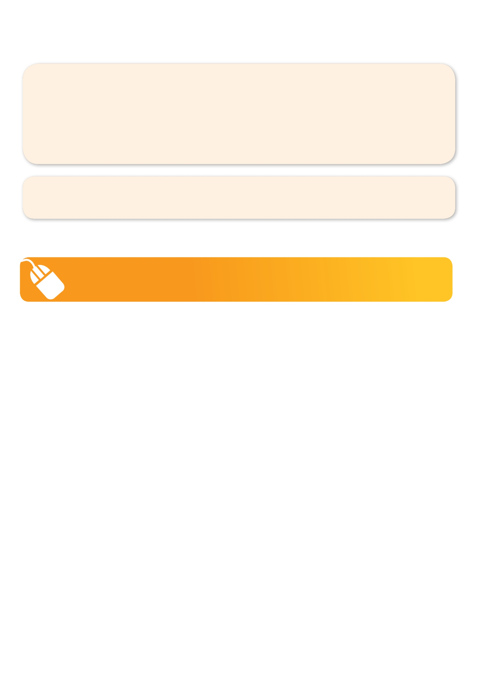
It’s here online enrolments !
To enrol, please visit www.kellysports.com.au or
fill out the enrolment form & send with a cheque or credit card details to:
Kelly Sports PO BOX 71, Moonee Vale, VIC, 3055.
Payment options available!
Do not leave enrolment forms at the school office

It’s here online enrolments !
To enrol, please visit www.kellysports.com.au or
fill out the enrolment form & send with a cheque or credit card details to:
Kelly Sports PO BOX 71, Moonee Vale, VIC, 3055.
Payment options available!
Do not leave enrolment forms at the school office

It’s here online enrolments !
To enrol, please visit www.kellysports.com.au or
fill out the enrolment form & send with a cheque or credit card details to:
Kelly Sports PO BOX 71, Moonee Vale, VIC, 3055.
Payment options available!
Do not leave enrolment forms at the school office

It’s here online enrolments !
To enrol, please visit www.kellysports.com.au or
fill out the enrolment form & send with a cheque or credit card details to:
Kelly Sports PO BOX 71, Moonee Vale, VIC, 3055.
Payment options available!
Do not leave enrolment forms at the school office

To enrol, please visit www.kellysports.com.au
or fill out the below enrolment form & send with a cheque or
credit card details to: PO BOX 71, Moonee Vale VIC 3055.
Do not leave enrolment forms at the school office.

ONLINE ENROLMENT
www.kellysports.com.au

ENROLMENT FORM
School: Year Level:
Name: Room No:
Address: Post Code:
Phone: Mobile/Work:
Email: Medical Conditions:

At the completion of after school clinics, does your child?  Go to after care  Get collected
Parents’ consent: I hereby authorise Kelly Sports to act on my behalf should my child require medical attention, and release
Kelly Sports Knox-Waverley from any liability for injury incurred by my child at Kelly Sports programmes.
Parent/Caregiver name: Signature:
Amount Paid: $ Credit card payment:  Visa  Master card
Card Number:     Expiry Date: /

