  P.O. Box 71, Moonee Vale 3055

**T** (03) 9384 2204

**F** (03) 9384 2205

**E** [lukebyles@kellysports.com.au](mailto:lukebyles@kellysports.com.au)

**HURRY**

**UP AND**

**ENROL!**

**SYNDAL SOUTH PRIMARY SCHOOL**

**WACKY WINTER SPORTS**

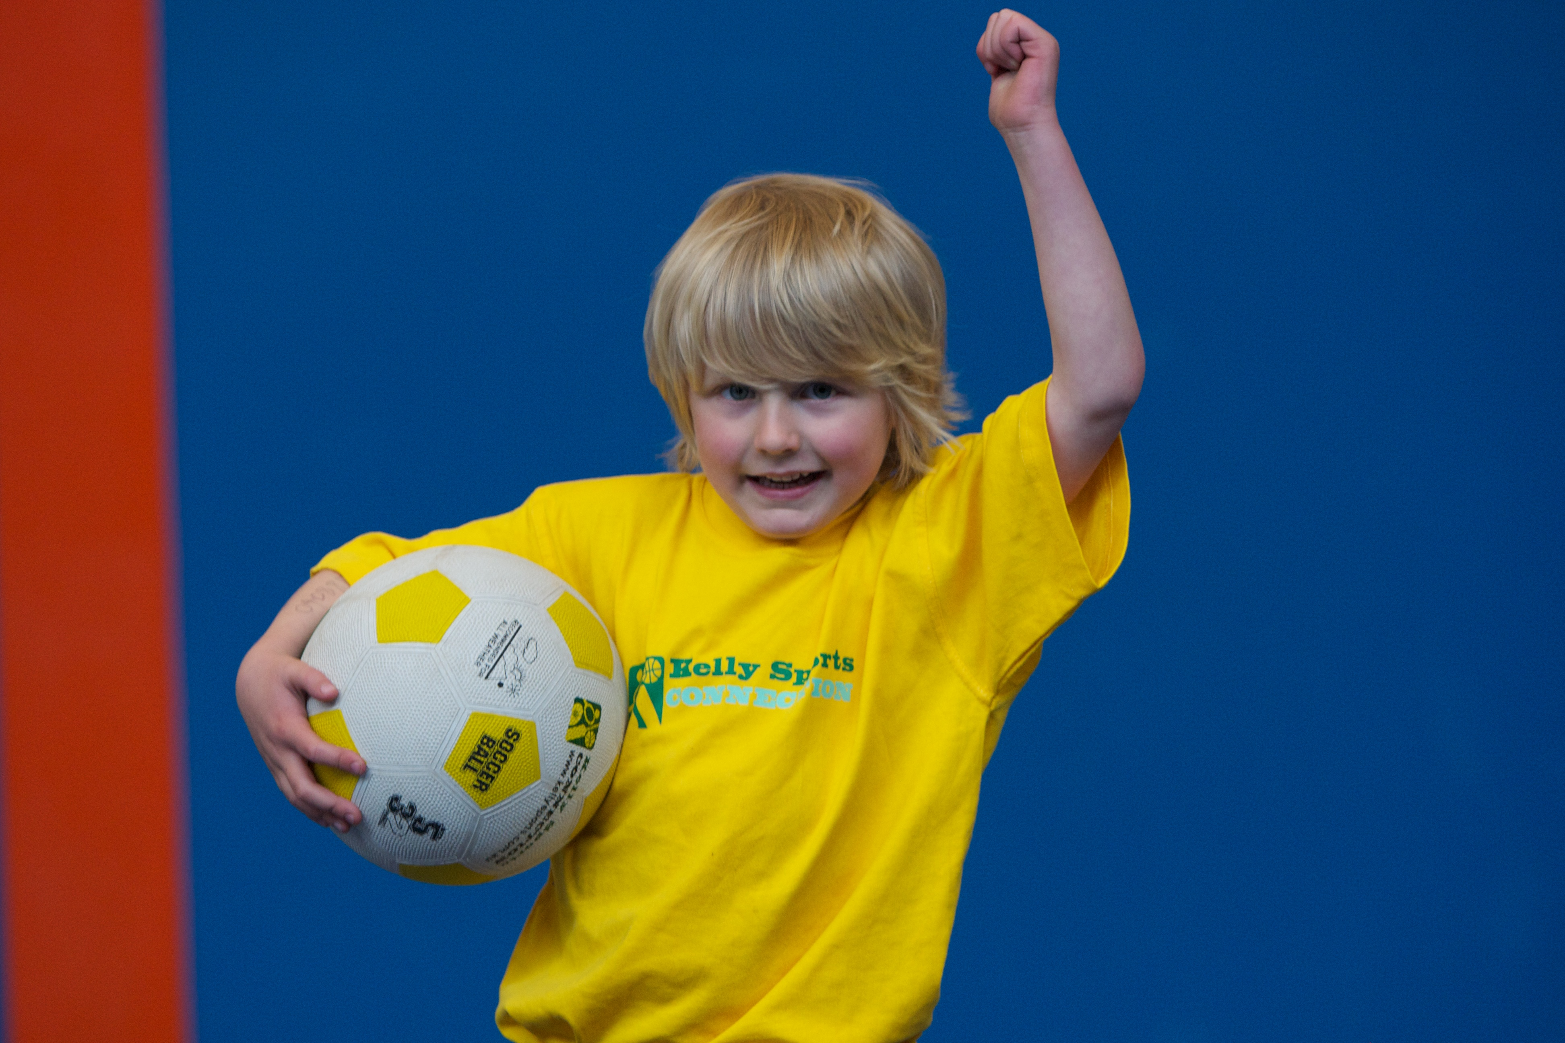

**FOOTBALL - SOCCER - DODGEBALL – TURBO TOUCH**This programme is a great way to challenge and improve your child’s motor skills and coordination within a FUN environment. We aim to develop and enhance ball skills, catching, kicking, throwing, co-operative skills and teamwork while improving strength, flexibility, hand-eye co-ordination and spatial awareness.

**WHEN:** Friday

**COMMENCING:** 18/7/14

**CONCLUDING:** 19/9/14

**TIME:** 3.40pm – 4.40pm

**YEAR LEVELS:** P – 4



**CIRCUS SKILLS**

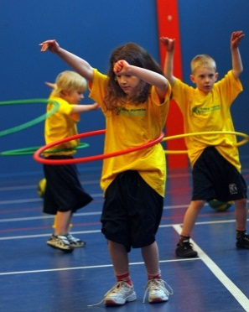

**KIDS YOU WILL LOVE THIS!**Learn to juggle, spin plates, use devil sticks and have lots of fun with all our exciting circus skills equipment.  This 10-week course includes skipping drills and a circus skills performance at the end of the term

**WHEN:** Friday

**COMMENCING:** 18/7/14

**CONCLUDING:** 19/9/14

**TIME:** 1.40pm – 2.30pm

**YEAR LEVELS:** P - 4



**COST: Sport $100 Circus $100**

**It’s here online enrolments !**

**To enrol**, please visit [www.kellysports.com.au](http://www.kellysports.com.au) or

fill out the enrolment form & **send** with a cheque or credit card details to:

Kelly Sports PO BOX 71, Moonee Vale, VIC, 3055.

Payment options available!

Do **not** leave enrolment forms at the school office

**VENUE: Syndal South Primary School**

**­**

**It’s here online enrolments !**

**To enrol**, please visit [www.kellysports.com.au](http://www.kellysports.com.au) or

fill out the enrolment form & **send** with a cheque or credit card details to:

Kelly Sports PO BOX 71, Moonee Vale, VIC, 3055.

Payment options available!

Do **not** leave enrolment forms at the school office

To enrol, please visit ww.kellysports.com.au

or fill out the below enrolment form & sendwith a cheque or credit

card details to: **PO BOX 71, Moonee Vale VIC 3055**. Payment options available! **Do not** leave enrolment forms at the school office.

**ONLINE ENROLMENT**

**www.kellysports.com.au**

**ENROLMENT FORM**

□ **Wacky Winter Sports** (After School) □ **Circus** (Lunch Time)

School: Year Level:

Name: Room No:

Address: Post Code:

Phone: Mobile/Work:

Email: Medical Conditions:

At the completion of after school clinics, does your child? □ Go to after care □ Get collected

**Parents’ consent: I hereby authorise Kelly Sports to act on my behalf should my child require medical attention, and release   
Kelly Sports Knox-Waverley from any liability for injury incurred by my child at Kelly Sports programmes.**

Parent/Caregiver name: Signature:

Amount Paid: $ Credit card payment: □ **Visa** □ **Master card**

Card Number: □□□□ □□□□ □□□□ □□□□ Expiry Date: □□/□□

**It’s here online enrolments !**

**To enrol**, please visit [www.kellysports.com.au](http://www.kellysports.com.au) or

fill out the enrolment form & **send** with a cheque or credit card details to:

Kelly Sports PO BOX 71, Moonee Vale, VIC, 3055.

Payment options available!

Do **not** leave enrolment forms at the school office

**It’s here online enrolments !**

**To enrol**, please visit [www.kellysports.com.au](http://www.kellysports.com.au) or

fill out the enrolment form & **send** with a cheque or credit card details to:

Kelly Sports PO BOX 71, Moonee Vale, VIC, 3055.

Payment options available!

Do **not** leave enrolment forms at the school office

**It’s here online enrolments !**

**To enrol**, please visit [www.kellysports.com.au](http://www.kellysports.com.au) or

fill out the enrolment form & **send** with a cheque or credit card details to:

Kelly Sports PO BOX 71, Moonee Vale, VIC, 3055.

Payment options available!

Do **not** leave enrolment forms at the school office