

P.O. Box 71, Moonee Vale 3055
T (03) 9384 2204
F (03) 9384 2205

E lukebyles@kellysports.com.au
HURRY
UP AND
ENROL!


SUNBURY PRIMARY SCHOOL
WACKY WINTER SPORTS

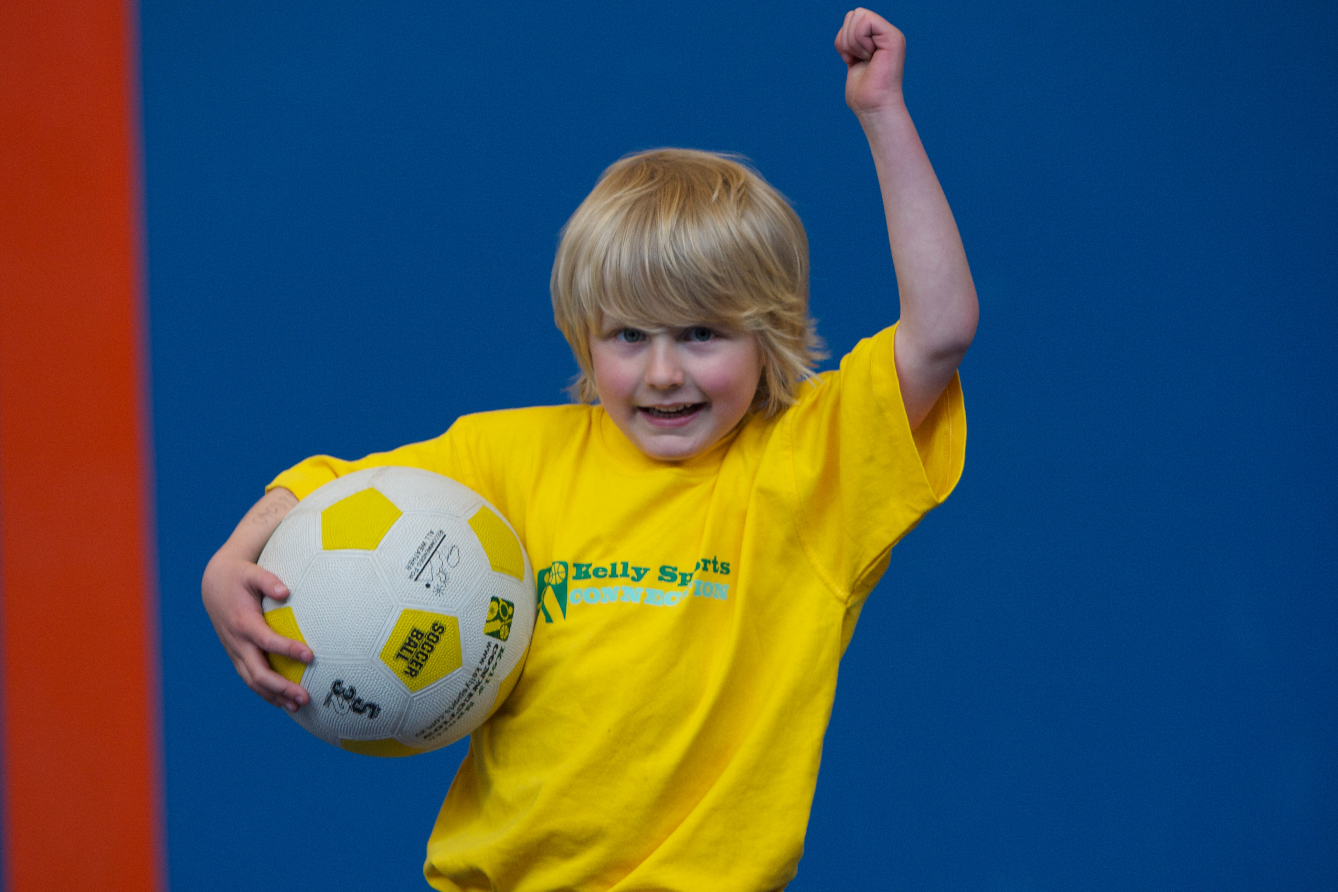
WHEN: Tuesday
COMMENCING: 15/7/14
CONCLUDING: 16/9/14
TIME: 3.40pm – 4.40pm
YEAR LEVELS: P – 4

FOOTBALL - SOCCER - DODGEBALL – TURBO TOUCH
This program is a great way to challenge and improve your child’s motor skills and coordination within a FUN environment. We aim to develop and enhance ball skills, catching, kicking, throwing, co-operative skills and teamwork while improving strength, flexibility, hand-eye co-ordination and spatial awareness.


GYM CLUB

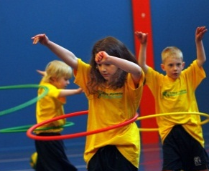
Our gym program is not just about having fun, it aims to provide all students with a range of gymnastics based shapes and skills including safe landings, forward and backward rolling, swinging and balancing as well as commencing work on handstands and cartwheels. We also include learning rhythmic gymnastics routines using hula hoops, ribbons and trampolines.

WHEN: Tuesday
COMMENCING: 15/7/14
CONCLUDING: 16/9/14
TIME: 3.40pm – 4.40pm
YEAR LEVELS: P – 4

COST: Sport $100 Gym $100
It’s here online enrolments !
To enrol, please visit www.kellysports.com.au or
fill out the enrolment form & send with a cheque or credit card details to:
Kelly Sports PO BOX 71, Moonee Vale, VIC, 3055.
Payment options available!
Do not leave enrolment forms at the school office

VENUE: Sunbury Primary School
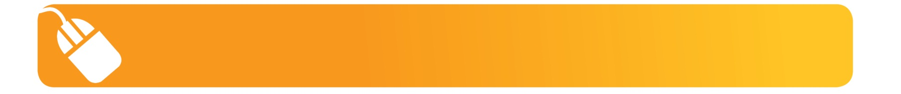
It’s here online enrolments !
To enrol, please visit www.kellysports.com.au or
fill out the enrolment form & send with a cheque or credit card details to:
Kelly Sports PO BOX 71, Moonee Vale, VIC, 3055.
Payment options available!
Do not leave enrolment forms at the school office

It’s here online enrolments !
To enrol, please visit www.kellysports.com.au or
fill out the enrolment form & send with a cheque or credit card details to:
Kelly Sports PO BOX 71, Moonee Vale, VIC, 3055.
Payment options available!
Do not leave enrolment forms at the school office

It’s here online enrolments !
To enrol, please visit www.kellysports.com.au or
fill out the enrolment form & send with a cheque or credit card details to:
Kelly Sports PO BOX 71, Moonee Vale, VIC, 3055.
Payment options available!
Do not leave enrolment forms at the school office

It’s here online enrolments !
To enrol, please visit www.kellysports.com.au or
fill out the enrolment form & send with a cheque or credit card details to:
Kelly Sports PO BOX 71, Moonee Vale, VIC, 3055.
Payment options available!
Do not leave enrolment forms at the school office

To enrol, please visit ww.kellysports.com.au
or fill out the below enrolment form & send with a cheque or credit
card details to: PO BOX 71, Moonee Vale VIC 3055. Payment options available! Do not leave enrolment forms at the school office.

ONLINE ENROLMENT
www.kellysports.com.au

ENROLMENT FORM
 Wacky Winter Sports (After School)  Gym Club (Lunch Time)
School: Year Level:
Name: Room No:
Address: Post Code:
Phone: Mobile/Work:
Email: Medical Conditions:

At the completion of after school clinics, does your child?  Go to after care  Get collected
Parents’ consent: I hereby authorise Kelly Sports to act on my behalf should my child require medical attention, and release
Kelly Sports North West from any liability for injury incurred by my child at Kelly Sports programmes.
Parent/Caregiver name: Signature:
Amount Paid: $ Credit card payment:  Visa  Master card
Card Number:     Expiry Date: /

