
P.O. Box 71, Moonee Vale 3055

T (03) 9384 2204
F (03) 9384 2205

E lukebyles@kellysports.com.au
Early Bird
$90
ENROL B4
4th of October

HURRY
UP AND
ENROL!


RUSKIN PARK PRIMARY SCHOOL
WACKY WINTER SPORTS

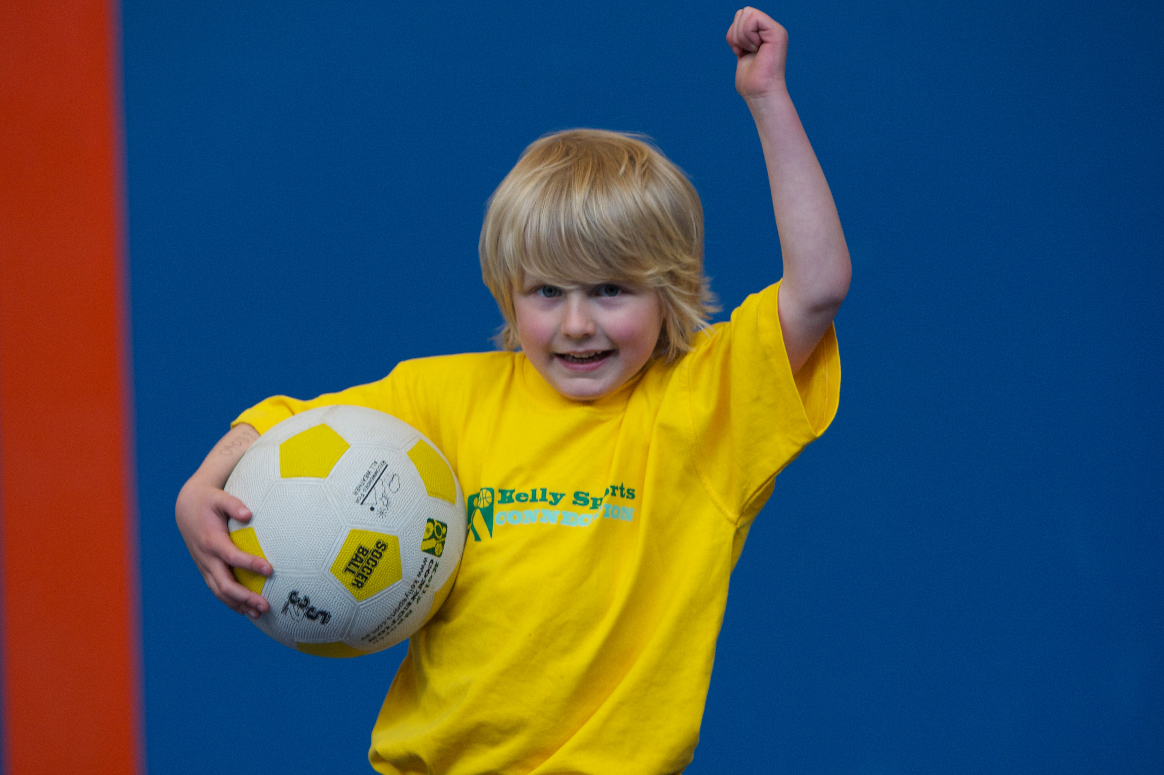
WHEN: Monday
COMMENCING: 14/7/14
CONCLUDING: 15/9/14
TIME: 3.40pm – 4.40pm
YEAR LEVELS: P – 4

FOOTBALL - SOCCER - DODGEBALL – TURBO TOUCH
This programme is a great way to challenge and improve your child’s motor skills and coordination within a FUN environment. We aim to develop and enhance ball skills, catching, kicking, throwing, co-operative skills and teamwork while improving strength, flexibility, hand-eye co-ordination and spatial awareness.


CIRCUS SKILLS

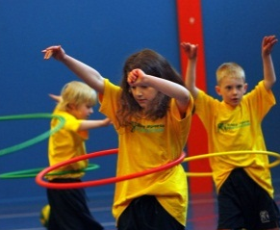
KIDS YOU WILL LOVE THIS! Learn to juggle, spin plates, use devil sticks and have lots of fun with all our exciting circus skills equipment. This 10-week course includes skipping drills and a circus skills performance at the end of the term.

WHEN: Monday
COMMENCING: 14/7/14
CONCLUDING: 15/9/14
TIME: 1.30pm – 2.30pm
YEAR LEVELS: P – 4

COST: Sport $100 Circus $100
It’s here online enrolments !
To enrol, please visit www.kellysports.com.au or
fill out the enrolment form & send with a cheque or credit card details to:
Kelly Sports PO BOX 71, Moonee Vale, VIC, 3055.
Payment options available!
Do not leave enrolment forms at the school office

VENUE: Ruskin Park Primary School
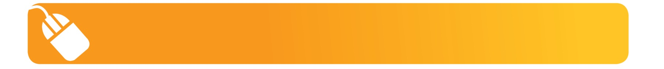
It’s here online enrolments !
To enrol, please visit www.kellysports.com.au or
fill out the enrolment form & send with a cheque or credit card details to:
Kelly Sports PO BOX 71, Moonee Vale, VIC, 3055.
Payment options available!
Do not leave enrolment forms at the school office

It’s here online enrolments !
To enrol, please visit www.kellysports.com.au or
fill out the enrolment form & send with a cheque or credit card details to:
Kelly Sports PO BOX 71, Moonee Vale, VIC, 3055.
Payment options available!
Do not leave enrolment forms at the school office

It’s here online enrolments !
To enrol, please visit www.kellysports.com.au or
fill out the enrolment form & send with a cheque or credit card details to:
Kelly Sports PO BOX 71, Moonee Vale, VIC, 3055.
Payment options available!
Do not leave enrolment forms at the school office

It’s here online enrolments !
To enrol, please visit www.kellysports.com.au or
fill out the enrolment form & send with a cheque or credit card details to:
Kelly Sports PO BOX 71, Moonee Vale, VIC, 3055.
Payment options available!
Do not leave enrolment forms at the school office

To enrol, please visit ww.kellysports.com.au
or fill out the below enrolment form & send with a cheque or credit
card details to: PO BOX 71, Moonee Vale VIC 3055. Payment options available! Do not leave enrolment forms at the school office.

ONLINE ENROLMENT
www.kellysports.com.au

ENROLMENT FORM
 Wacky Winter Sports (After School)  Circus (Lunch Time)
School: Year Level:
Name: Room No:
Address: Post Code:
Phone: Mobile/Work:
Email: Medical Conditions:

At the completion of after school clinics, does your child?  Go to after care  Get collected
Parents’ consent: I hereby authorise Kelly Sports to act on my behalf should my child require medical attention, and release
Kelly Sports Mooroolbark from any liability for injury incurred by my child at Kelly Sports programmes.
Parent/Caregiver name: Signature:
Amount Paid: $ Credit card payment:  Visa  Master card
Card Number:     Expiry Date: /

