  P.O. Box 71, Moonee Vale 3055

 **T** (03) 9384 2204

**F** (03) 9384 2205

**E** chrishoegel@kellysports.com.au

**Hurry**

**Places  
Limited**

 **RINGWOOD HEIGHTS PRIMARY SCHOOL**

**WACKY WINTER SPORTS**

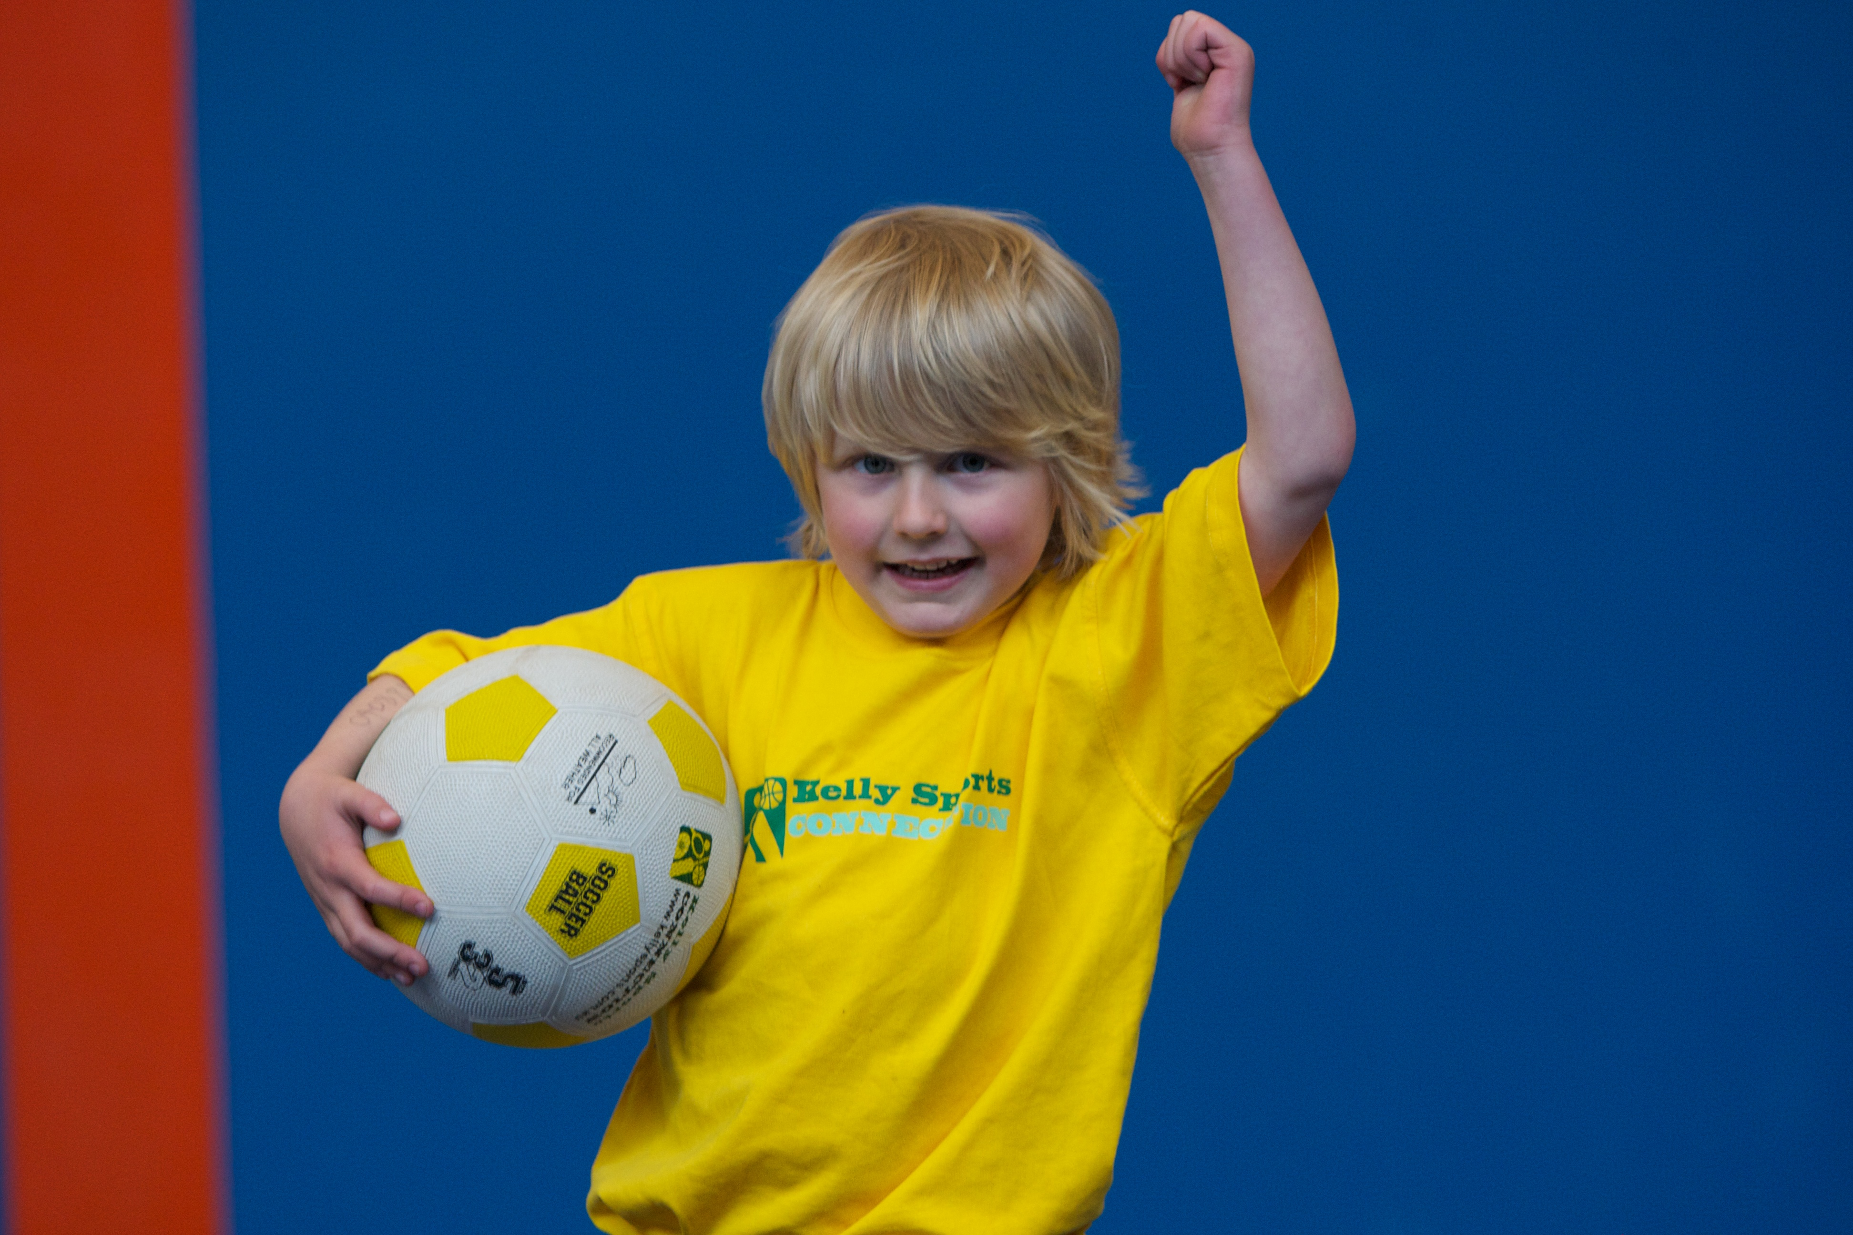

**FOOTBALL - SOCCER - DODGEBALL – TURBO TOUCH**   
This programme is a great way to challenge and improve your child’s motor skills and coordination within a FUN environment. We aim to develop and enhance ball skills, catching, kicking, throwing, co-operative skills and teamwork while improving strength, flexibility, hand-eye co-ordination and spatial awareness.

**WHEN:** Wednesday

**COMMENCING:** 16/7/14

**CONCLUDING:** 17/9/14

**TIME:** 3.40pm – 4.40pm

**YEAR LEVELS:** P – 4



**GYM CLUB**

Our gym program is not just about having fun, it aims to provide all students with a range of gymnastics based shapes and skills including safe landings, forward and backward rolling, swinging and balancing as well as commencing work on handstands and cartwheels. We also include learning rhythmic gymnastics routines using hula hoops, ribbons and trampolines.

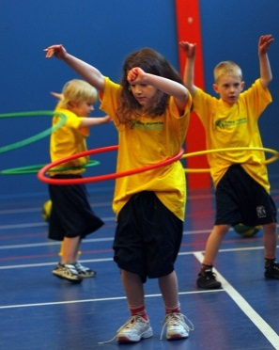

**WHEN:** Friday

**COMMENCING:** 18/7/14

**CONCLUDING:** 19/9/14

**TIME:** 1.00pm – 1.50pm

**YEAR LEVELS:** P – 4



**COST: Sport $100 Gym $100**

**It’s here online enrolments !**

**To enrol**, please visit [www.kellysports.com.au](http://www.kellysports.com.au) or

fill out the enrolment form & **send** with a cheque or credit card details to:

Kelly Sports PO BOX 71, Moonee Vale, VIC, 3055.

Payment options available!

Do **not** leave enrolment forms at the school office

**VENUE: Ringwood Heights Primary School**

**­**

**It’s here online enrolments !**

**To enrol**, please visit [www.kellysports.com.au](http://www.kellysports.com.au) or

fill out the enrolment form & **send** with a cheque or credit card details to:

Kelly Sports PO BOX 71, Moonee Vale, VIC, 3055.

Payment options available!

Do **not** leave enrolment forms at the school office

To enrol, please visit **w**ww.kellysports.com.au

or fill out the below enrolment form & sendwith a cheque or credit

card details to: **PO BOX 71, Moonee Vale VIC 3055**. Payment options available! **Do not** leave enrolment forms at the school office.

**ONLINE ENROLMENT**

**www.kellysports.com.au**

**ENROLMENT FORM**

□ **Wacky Winter Sports** (After School) □ **Gym Club** (Lunch)

School: Year Level:

Name: Room No:

Address: Post Code:

Phone: Mobile/Work:

Email: Medical Conditions:

At the completion of after school clinics, does your child? □ Go to after care □ Get collected

**Parents’ consent: I hereby authorise Kelly Sports to act on my behalf should my child require medical attention, and release   
Kelly Sports Mooroolbark from any liability for injury incurred by my child at Kelly Sports programmes.**

Parent/Caregiver name: Signature:

Amount Paid: $ Credit card payment: □ **Visa** □ **Master card**

Card Number: □□□□ □□□□ □□□□ □□□□ Expiry Date: □□/□□

**It’s here online enrolments !**

**To enrol**, please visit [www.kellysports.com.au](http://www.kellysports.com.au) or

fill out the enrolment form & **send** with a cheque or credit card details to:

Kelly Sports PO BOX 71, Moonee Vale, VIC, 3055.

Payment options available!

Do **not** leave enrolment forms at the school office

**It’s here online enrolments !**

**To enrol**, please visit [www.kellysports.com.au](http://www.kellysports.com.au) or

fill out the enrolment form & **send** with a cheque or credit card details to:

Kelly Sports PO BOX 71, Moonee Vale, VIC, 3055.

Payment options available!

Do **not** leave enrolment forms at the school office

**It’s here online enrolments !**

**To enrol**, please visit [www.kellysports.com.au](http://www.kellysports.com.au) or

fill out the enrolment form & **send** with a cheque or credit card details to:

Kelly Sports PO BOX 71, Moonee Vale, VIC, 3055.

Payment options available!

Do **not** leave enrolment forms at the school office