

P.O. Box 71, Moonee Vale 3055
T (03) 9384 2204
F (03) 9384 2205
Early Bird
$90
ENROL B4
4th October

HURRY
UP AND
ENROL!

E lukebyles@kellysports.com.au


MONT ALBERT PRIMARY SCHOOL


WORLD CUP SOCCER

LOVE THE WORLD CUP LOOK NO FURTHER The journey to stardom begins here at the Kelly Sports 10 week World Cup Soccer. Our talented qualified and enthusiastic coaches will have your children kicking goals in no time, developing skills in passing, dribbling, heading and of course kicking their team to glory.

WHEN: Monday
COMMENCING: 14/7/14
CONCLUDING: 15/9/14
TIME: 3.40pm – 4.40pm
YEAR LEVELS: 4-6

COST: $100
It’s here online enrolments !
To enrol, please visit www.kellysports.com.au or
fill out the enrolment form & send with a cheque or credit card details to:
Kelly Sports PO BOX 71, Moonee Vale, VIC, 3055.
Payment options available!
Do not leave enrolment forms at the school office

VENUE: Mont Albert Primary School
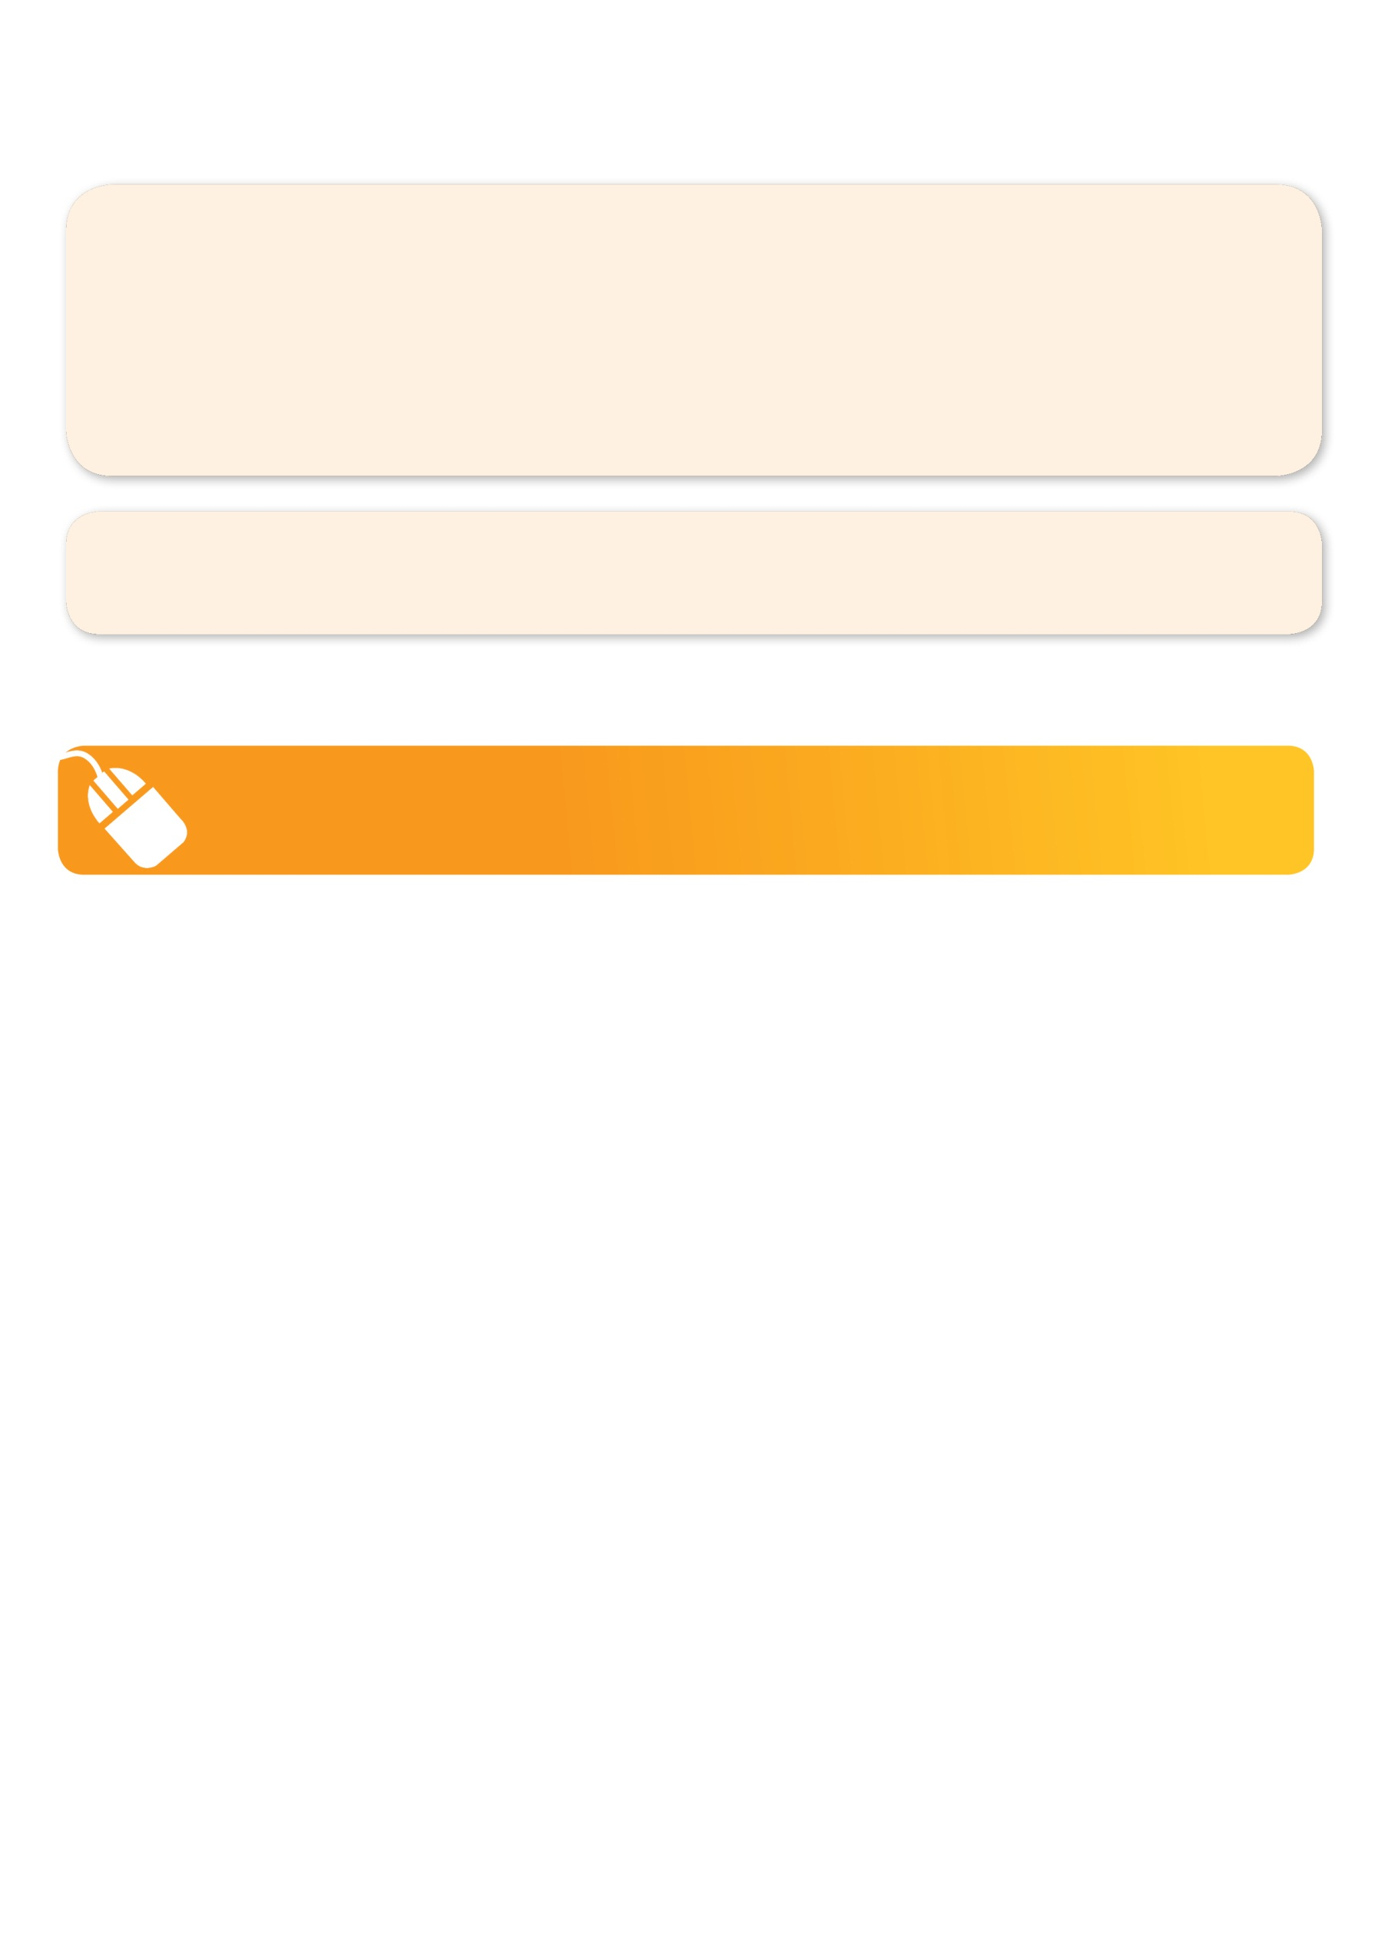
It’s here online enrolments !
To enrol, please visit www.kellysports.com.au or
fill out the enrolment form & send with a cheque or credit card details to:
Kelly Sports PO BOX 71, Moonee Vale, VIC, 3055.
Payment options available!
Do not leave enrolment forms at the school office

It’s here online enrolments !
To enrol, please visit www.kellysports.com.au or
fill out the enrolment form & send with a cheque or credit card details to:
Kelly Sports PO BOX 71, Moonee Vale, VIC, 3055.
Payment options available!
Do not leave enrolment forms at the school office

It’s here online enrolments !
To enrol, please visit www.kellysports.com.au or
fill out the enrolment form & send with a cheque or credit card details to:
Kelly Sports PO BOX 71, Moonee Vale, VIC, 3055.
Payment options available!
Do not leave enrolment forms at the school office

It’s here online enrolments !
To enrol, please visit www.kellysports.com.au or
fill out the enrolment form & send with a cheque or credit card details to:
Kelly Sports PO BOX 71, Moonee Vale, VIC, 3055.
Payment options available!
Do not leave enrolment forms at the school office

To enrol, please visit www.kellysports.com.au
or fill out the below enrolment form & send with a cheque or
credit card details to: PO BOX 71, Moonee Vale VIC 3055.
Do not leave enrolment forms at the school office.

ONLINE ENROLMENT
www.kellysports.com.au

ENROLMENT FORM
School: Year Level:
Name: Room No:
Address: Post Code:
Phone: Mobile/Work:
Email: Medical Conditions:

At the completion of after school clinics, does your child?  Go to after care  Get collected
Parents’ consent: I hereby authorise Kelly Sports to act on my behalf should my child require medical attention, and release
Kelly Sports Camberwell from any liability for injury incurred by my child at Kelly Sports programmes.
Parent/Caregiver name: Signature:
Amount Paid: $ Credit card payment:  Visa  Master card
Card Number:     Expiry Date: /

