

P.O. Box 71, Moonee Vale 3055
T (03) 9384 2204
F (03) 9384 2205

E lukebyles@kellysports.com.au
Early Bird
$90
ENROL B4
4th of October

HURRY
UP AND
ENROL!


KERRIMUIR PRIMARY SCHOOL
WACKY WINTER SPORTS

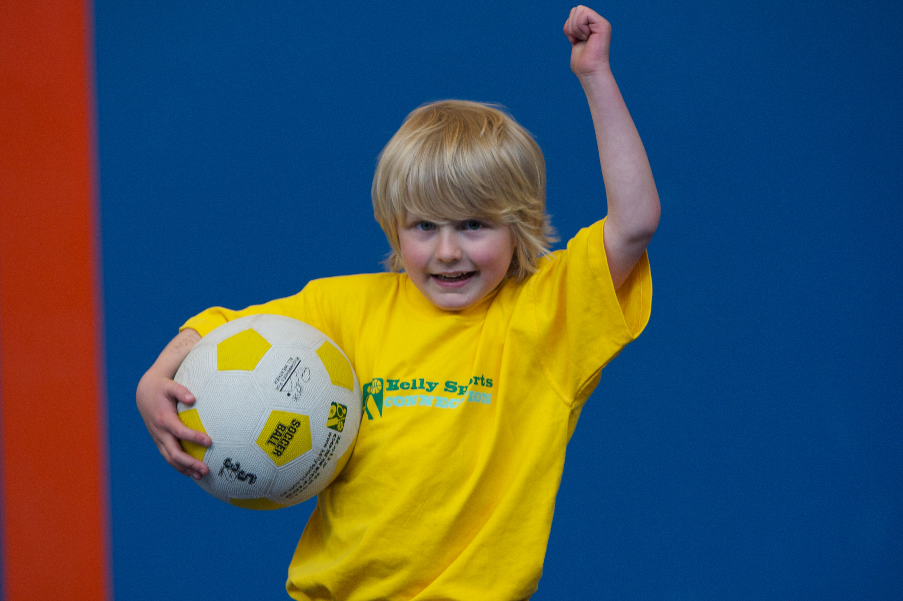
WHEN: Monday
COMMENCING: 14/7/14
CONCLUDING: 15/9/14
TIME: 3.40pm – 4.40pm
YEAR LEVELS: P – 4

FOOTBALL - SOCCER - DODGEBALL – TURBO TOUCH
This programme is a great way to challenge and improve your child’s motor skills and coordination within a FUN environment. We aim to develop and enhance ball skills, catching, kicking, throwing, co-operative skills and teamwork while improving strength, flexibility, hand-eye co-ordination and spatial awareness.


DANCING DYNAMOS!

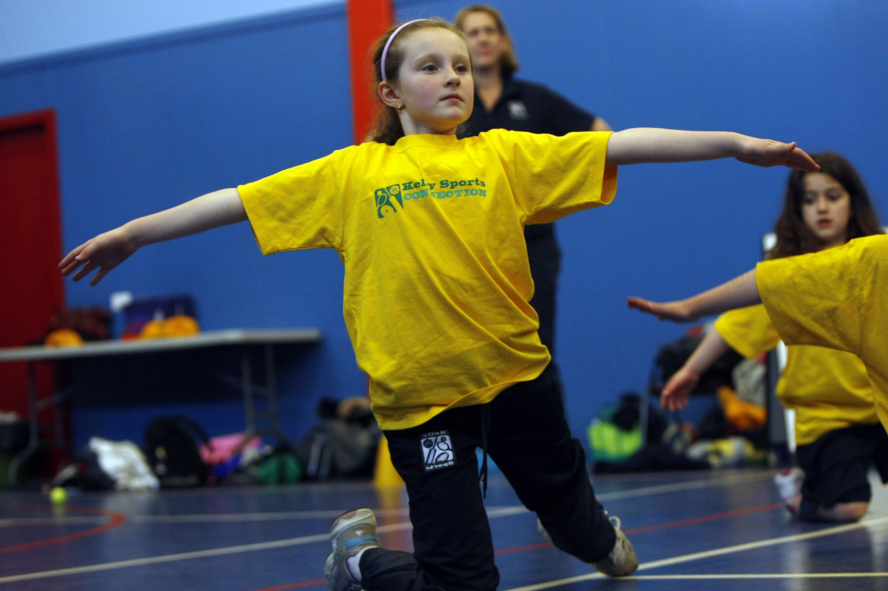
Dance classes are a fantastic way for your child to develop their self-awareness, coordination and musicality, while socialising with other children. Dance to the latest hits while learning routines, dance steps, making friends and having loads of fun at the same time!!

WHEN: Tuesday
COMMENCING: 15/7/14
CONCLUDING: 16/9/14
TIME: 1.40pm – 2.30pm
YEAR LEVELS: P – 4

COST: Sports $100 Dance $100
It’s here online enrolments !
To enrol, please visit www.kellysports.com.au or
fill out the enrolment form & send with a cheque or credit card details to:
Kelly Sports PO BOX 71, Moonee Vale, VIC, 3055.
Payment options available!
Do not leave enrolment forms at the school office

VENUE: Kerrimuir Primary School
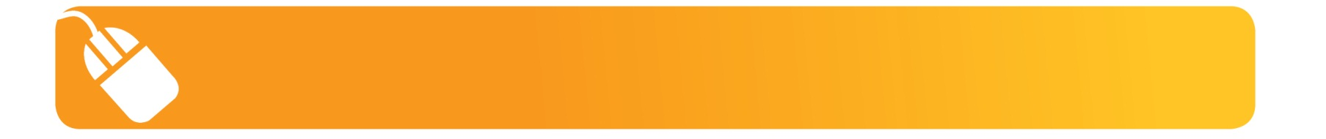
It’s here online enrolments !
To enrol, please visit www.kellysports.com.au or
fill out the enrolment form & send with a cheque or credit card details to:
Kelly Sports PO BOX 71, Moonee Vale, VIC, 3055.
Payment options available!
Do not leave enrolment forms at the school office

It’s here online enrolments !
To enrol, please visit www.kellysports.com.au or
fill out the enrolment form & send with a cheque or credit card details to:
Kelly Sports PO BOX 71, Moonee Vale, VIC, 3055.
Payment options available!
Do not leave enrolment forms at the school office

It’s here online enrolments !
To enrol, please visit www.kellysports.com.au or
fill out the enrolment form & send with a cheque or credit card details to:
Kelly Sports PO BOX 71, Moonee Vale, VIC, 3055.
Payment options available!
Do not leave enrolment forms at the school office

It’s here online enrolments !
To enrol, please visit www.kellysports.com.au or
fill out the enrolment form & send with a cheque or credit card details to:
Kelly Sports PO BOX 71, Moonee Vale, VIC, 3055.
Payment options available!
Do not leave enrolment forms at the school office

To enrol, please visit ww.kellysports.com.au
or fill out the below enrolment form & send with a cheque or credit
card details to: PO BOX 71, Moonee Vale VIC 3055. Payment options available! Do not leave enrolment forms at the school office.

ONLINE ENROLMENT
www.kellysports.com.au

ENROLMENT FORM
 Wacky Winter Sports (After School)  Dancing Dynamos (Lunch Time)
School: Year Level:
Name: Room No:
Address: Post Code:
Phone: Mobile/Work:
Email: Medical Conditions:

At the completion of after school clinics, does your child?  Go to after care  Get collected
Parents’ consent: I hereby authorise Kelly Sports to act on my behalf should my child require medical attention, and release
Kelly Sports Blackburn from any liability for injury incurred by my child at Kelly Sports programmes.
Parent/Caregiver name: Signature:
Amount Paid: $ Credit card payment:  Visa  Master card
Card Number:     Expiry Date: /

