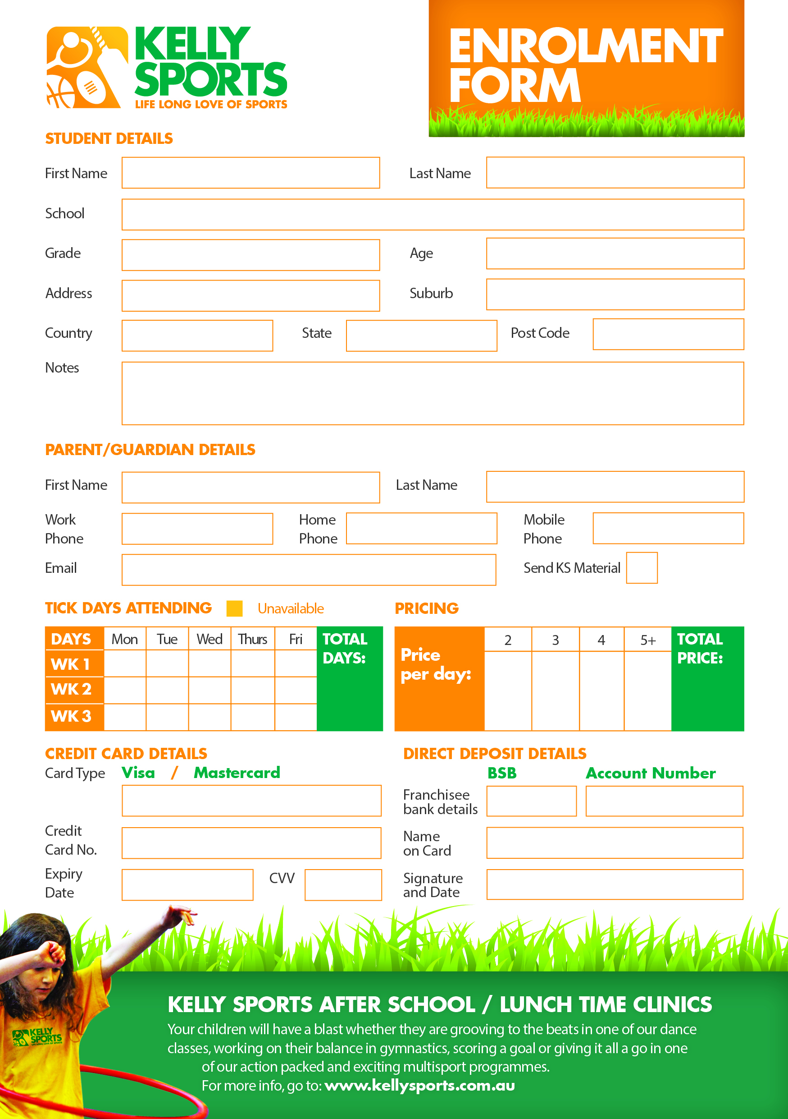

**633000**

**122016876**

$30  
per  
day

$35

$140

$105

$70

**$**