  P.O. Box 71, Moonee Vale 3055

**T** (03) 9384 2204

**F** (03) 9384 2205

**E** [lukebyles@kellysports.com.au](mailto:lukebyles@kellysports.com.au)

**HURRY**

**UP AND**

**ENROL!**

**GREENVALE PRIMARY SCHOOL**

**WACKY WINTER SPORTS**

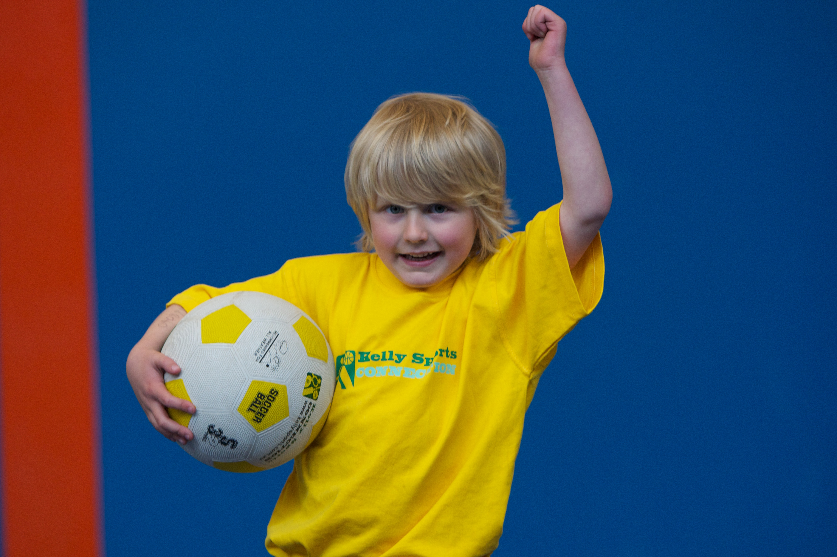

**FOOTBALL - SOCCER - DODGEBALL – TURBO TOUCH**   
This program is a great way to challenge and improve your child’s motor skills and coordination within a FUN environment. We aim to develop and enhance ball skills, catching, kicking, throwing, co-operative skills and teamwork while improving strength, flexibility, hand-eye co-ordination and spatial awareness.

**WHEN:** Thursday

**COMMENCING:** 17/7/14

**CONCLUDING:** 18/9/14

**TIME:** 3.40pm – 4.40pm

**YEAR LEVELS:** P – 4



**CIRCUS SKILLS**

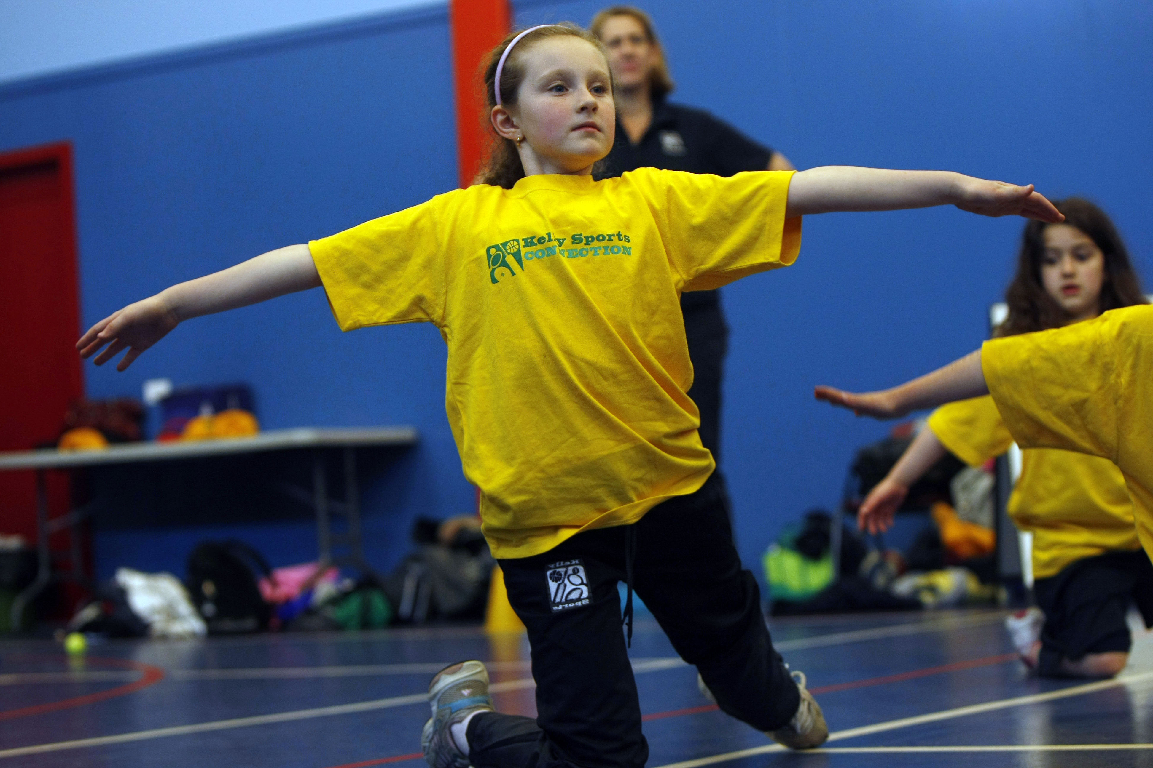

**WHEN:** Thursday

**COMMENCING:** 17/7/14

**CONCLUDING:** 18/9/14

**TIME:** 3.40pm – 4.40pm

**YEAR LEVELS:** P – 4

**KIDS YOU WILL LOVE THIS!**Learn to juggle, spin plates, use devil sticks and have lots of fun with all our exciting circus skills equipment.  This 10-week course includes skipping drills and a circus skills performance at the end of the term.



**COST: Sport $100 Circus $100**

**It’s here online enrolments !**

**To enrol**, please visit [www.kellysports.com.au](http://www.kellysports.com.au) or

fill out the enrolment form & **send** with a cheque or credit card details to:

Kelly Sports PO BOX 71, Moonee Vale, VIC, 3055.

Payment options available!

Do **not** leave enrolment forms at the school office

**VENUE: Greenvale Primary School**

**­**

**It’s here online enrolments !**

**To enrol**, please visit [www.kellysports.com.au](http://www.kellysports.com.au) or

fill out the enrolment form & **send** with a cheque or credit card details to:

Kelly Sports PO BOX 71, Moonee Vale, VIC, 3055.

Payment options available!

Do **not** leave enrolment forms at the school office

To enrol, please visit ww.kellysports.com.au

or fill out the below enrolment form & sendwith a cheque or credit

card details to: **PO BOX 71, Moonee Vale VIC 3055**. Payment options available! **Do not** leave enrolment forms at the school office.

**ONLINE ENROLMENT**

**www.kellysports.com.au**

**ENROLMENT FORM**

□ **Wacky Winter Sports** (After School) □ **Circus Skills** (After School)

School: Year Level:

Name: Room No:

Address: Post Code:

Phone: Mobile/Work:

Email: Medical Conditions:

At the completion of after school clinics, does your child? □ Go to after care □ Get collected

**Parents’ consent: I hereby authorise Kelly Sports to act on my behalf should my child require medical attention, and release   
Kelly Sports North West from any liability for injury incurred by my child at Kelly Sports programmes.**

Parent/Caregiver name: Signature:

Amount Paid: $ Credit card payment: □ **Visa** □ **Master card**

Card Number: □□□□ □□□□ □□□□ □□□□ Expiry Date: □□/□□

**It’s here online enrolments !**

**To enrol**, please visit [www.kellysports.com.au](http://www.kellysports.com.au) or

fill out the enrolment form & **send** with a cheque or credit card details to:

Kelly Sports PO BOX 71, Moonee Vale, VIC, 3055.

Payment options available!

Do **not** leave enrolment forms at the school office

**It’s here online enrolments !**

**To enrol**, please visit [www.kellysports.com.au](http://www.kellysports.com.au) or

fill out the enrolment form & **send** with a cheque or credit card details to:

Kelly Sports PO BOX 71, Moonee Vale, VIC, 3055.

Payment options available!

Do **not** leave enrolment forms at the school office

**It’s here online enrolments !**

**To enrol**, please visit [www.kellysports.com.au](http://www.kellysports.com.au) or

fill out the enrolment form & **send** with a cheque or credit card details to:

Kelly Sports PO BOX 71, Moonee Vale, VIC, 3055.

Payment options available!

Do **not** leave enrolment forms at the school office