
P.O. Box 71, Moonee Vale 3055
T (03) 9384 2204
F (03) 9384 2205
Special O

E lukebyles@kellysports.com.au


GOODSTART CANTERBURY ROAD BOX HILL
FUNDAMENTAL
SKILLS PROGRAM

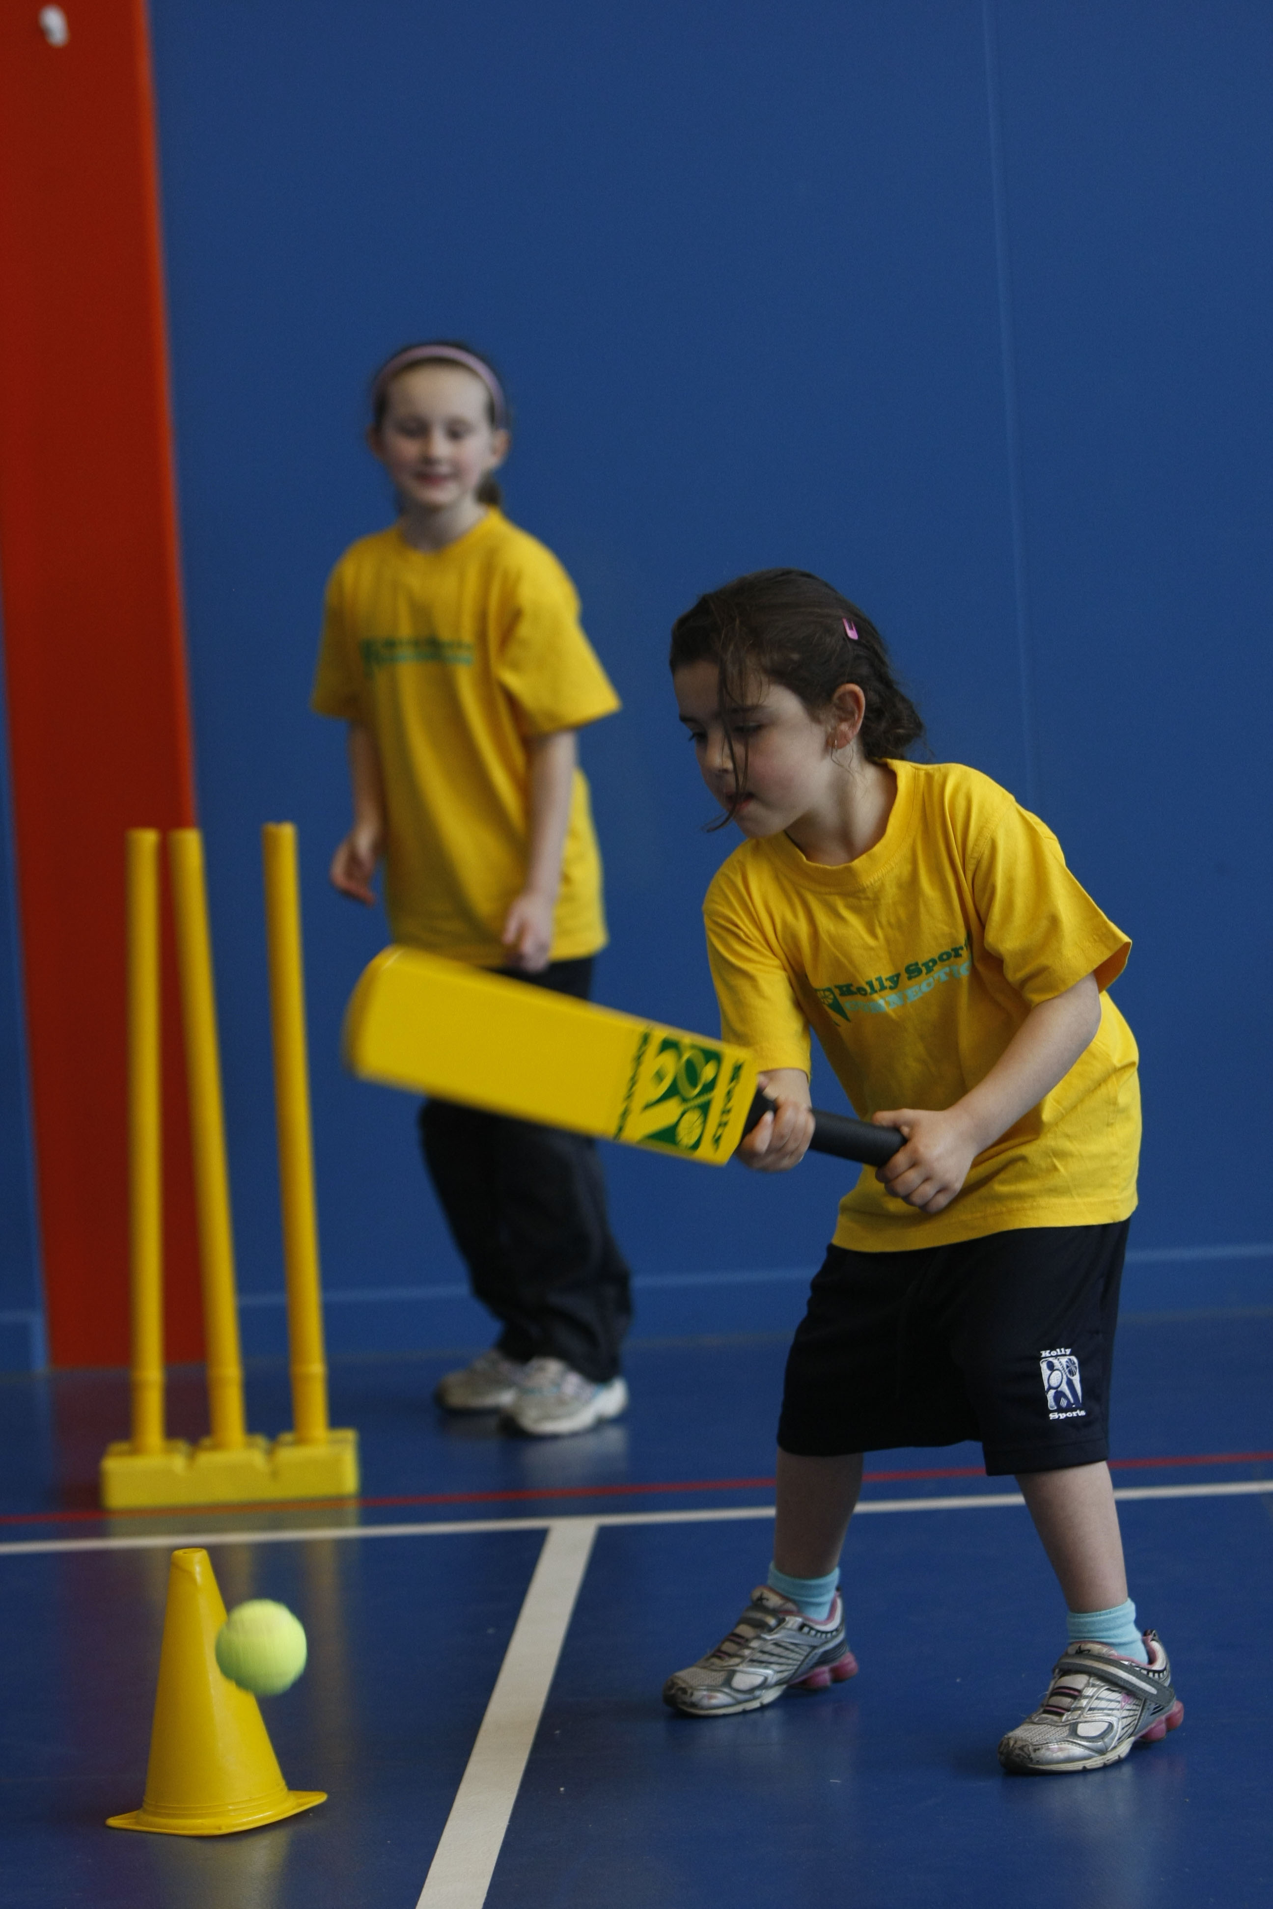

Kelly Sports runs programmes to teach children the fundamentals of sport. This 10-WEEK program is all-inclusive with high participation. Our key aims are to develop and enhance the following skills – running, jumping, catching, throwing, passing, kicking and striking:
The Fundamental Skills Program includes:
- Motor Skill Development
- Balance and Hand- Eye Cordination
- Introduction to a variety of sports -Soccer, Basketball, Cricket, Football, Olympic Games and more.

WHEN: Tuesday
COMMENCING: 15/7/14
CONCLUDING: 16/9/14
TIME: 2.15pm – 2.45pm

COST: $75
It’s here online enrolments !
To enrol, please visit www.kellysports.com.au or
fill out the enrolment form & send with a cheque or credit card details to:
Kelly Sports PO BOX 71, Moonee Vale, VIC, 3055.
Payment options available!
Do not leave enrolment forms at the school office

VENUE: Goodstart Early Learning Canterbury Road
It’s here online enrolments !
To enrol, please visit www.kellysports.com.au or
fill out the enrolment form & send with a cheque or credit card details to:
Kelly Sports PO BOX 71, Moonee Vale, VIC, 3055.
Payment options available!
Do not leave enrolment forms at the school office

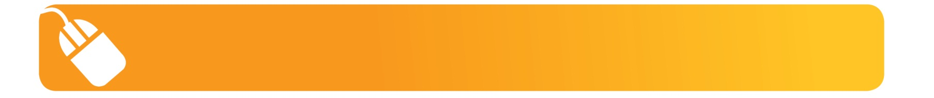
It’s here online enrolments !
To enrol, please visit www.kellysports.com.au or
fill out the enrolment form & send with a cheque or credit card details to:
Kelly Sports PO BOX 71, Moonee Vale, VIC, 3055.
Payment options available!
Do not leave enrolment forms at the school office

It’s here online enrolments !
To enrol, please visit www.kellysports.com.au or
fill out the enrolment form & send with a cheque or credit card details to:
Kelly Sports PO BOX 71, Moonee Vale, VIC, 3055.
Payment options available!
Do not leave enrolment forms at the school office

It’s here online enrolments !
To enrol, please visit www.kellysports.com.au or
fill out the enrolment form & send with a cheque or credit card details to:
Kelly Sports PO BOX 71, Moonee Vale, VIC, 3055.
Payment options available!
Do not leave enrolment forms at the school office

To enrol, please visit www.kellysports.com.au
or fill out the below enrolment form & send with a cheque or credit card details to: PO BOX 71, Moonee Vale VIC 3055. Payment options available!

ONLINE ENROLMENT
www.kellysports.com.au

ENROLMENT FORM

School: Year Level:
Name: Room No:
Address: Post Code:
Phone: Mobile/Work:
Email: Medical Conditions:

Parents’ consent: I hereby authorise Kelly Sports to act on my behalf should my child require medical attention, and release
Kelly Sports Blackburn from any liability for injury incurred by my child at Kelly Sports programmes.
Parent/Caregiver name: Signature:
Amount Paid: $ Credit card payment:  Visa  Mastercard
Card Number:     Expiry Date: /

