

P.O. Box 71, Moonee Vale 3055
T (03) 9384 2204
F (03) 9384 2205

E lukebyles@kellysports.com.au
HURRY
UP AND
ENROL!


GOOD SAMARITAN PRIMARY SCHOOL
WORLD CUP SOCCER

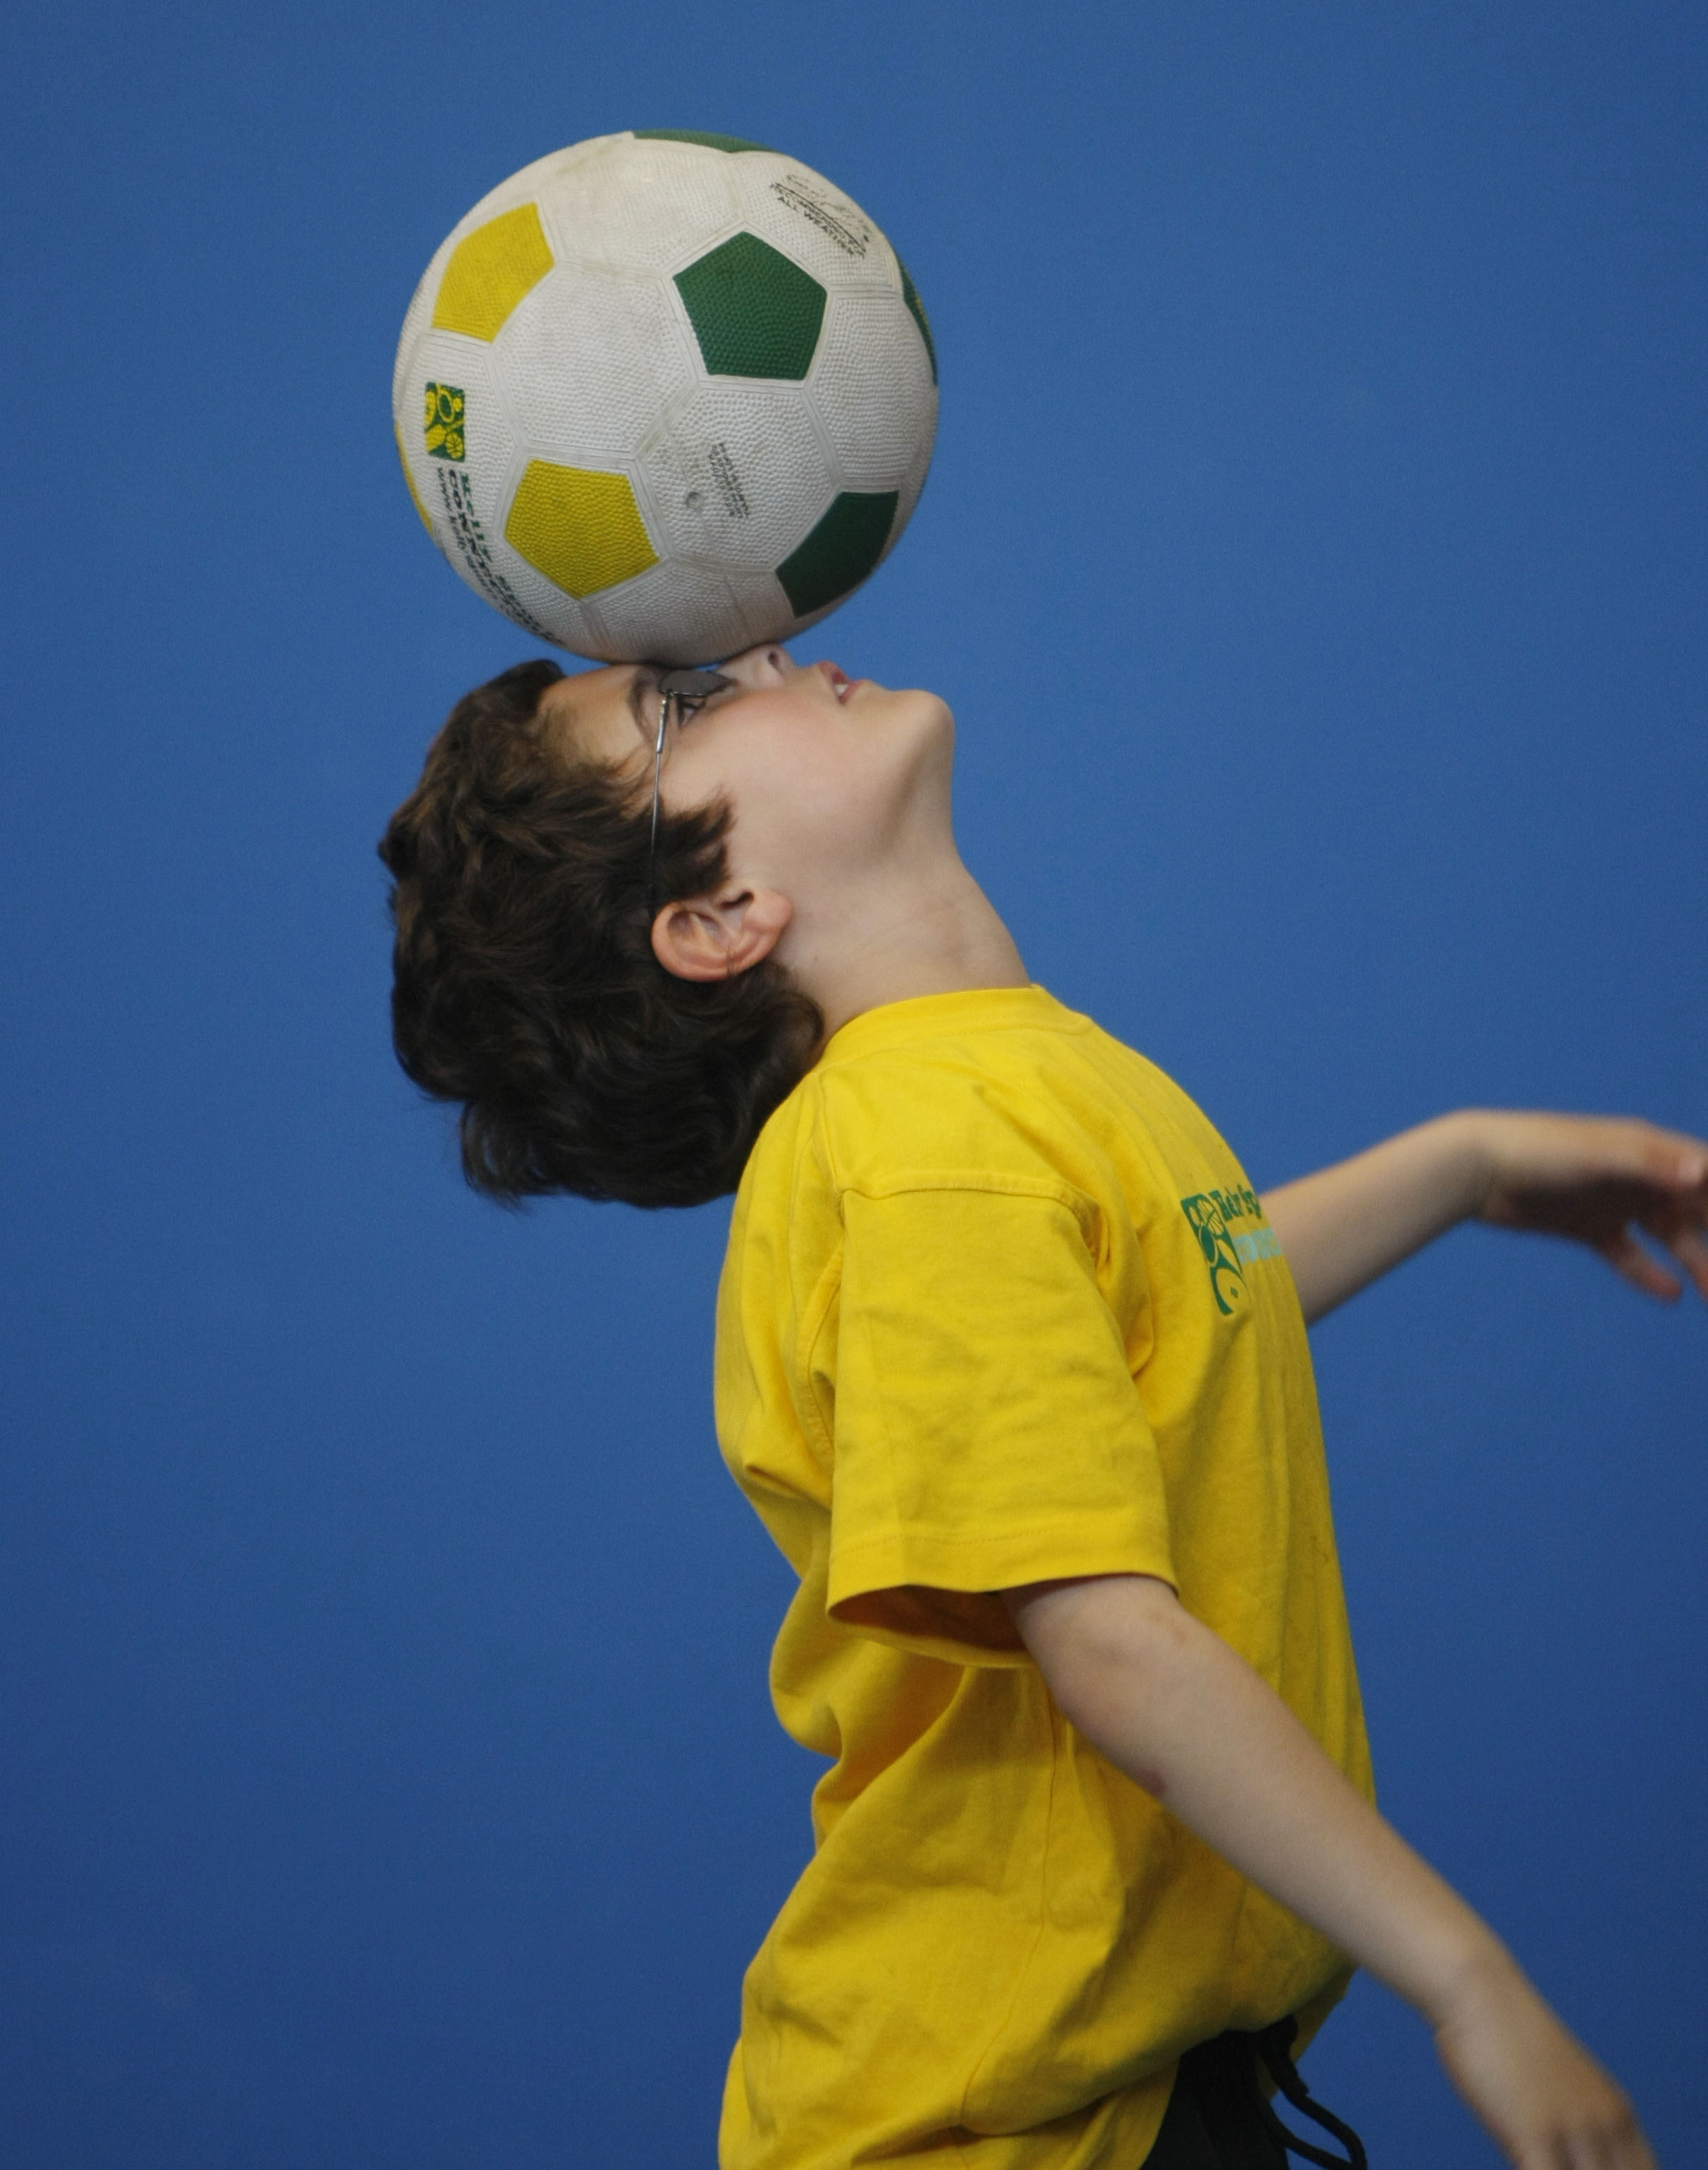
WHEN: Friday
COMMENCING: 18/7/14
CONCLUDING: 19/9/14
TIME: 3.25pm – 4.25pm
YEAR LEVELS: P – 4

LOVE THE WORLD CUP LOOK NO FURTHER The journey to stardom begins here at the Kelly Sports 10 week World Cup Soccer. Our talented qualified and enthusiastic coaches will have your children kicking goals in no time, developing skills in passing, dribbling, heading and of course kicking their team to glory.

CIRCUS SKILLS

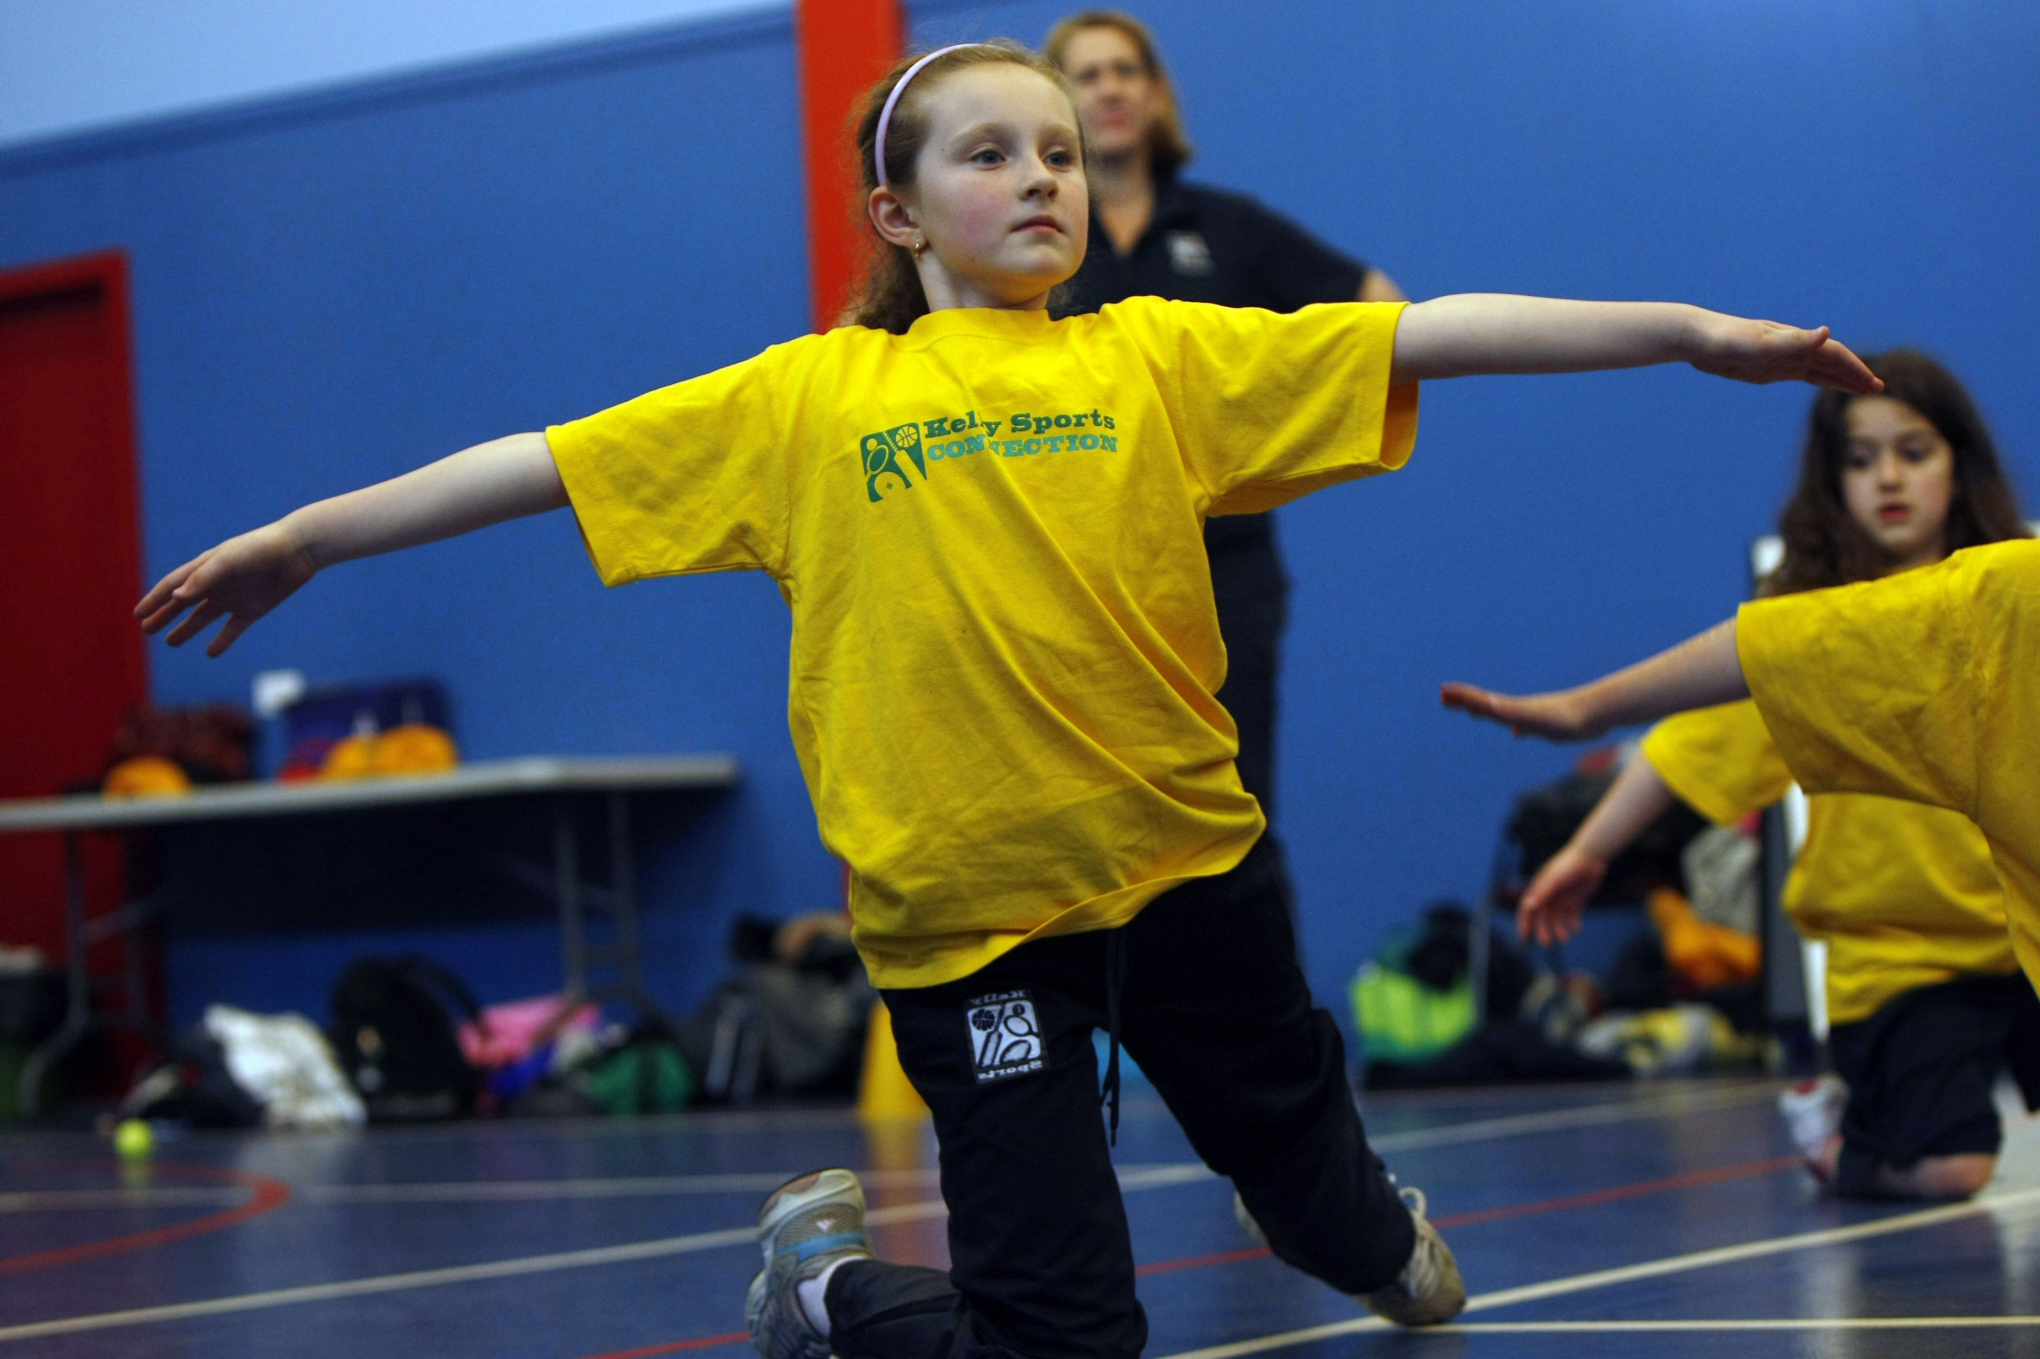
KIDS YOU WILL LOVE THIS! Learn to juggle, spin plates, use devil sticks and have lots of fun with all our exciting circus skills equipment. This 10-week course includes skipping drills and a circus skills performance at the end of the term.
WHEN: Friday
COMMENCING: 18/7/14
CONCLUDING: 19/9/14
TIME: 1.30pm – 2.10pm
YEAR LEVELS: P – 4

COST: Soccer $100 Circus $100
It’s here online enrolments !
To enrol, please visit www.kellysports.com.au or
fill out the enrolment form & send with a cheque or credit card details to:
Kelly Sports PO BOX 71, Moonee Vale, VIC, 3055.
Payment options available!
Do not leave enrolment forms at the school office

VENUE: Good Samaritan Primary School
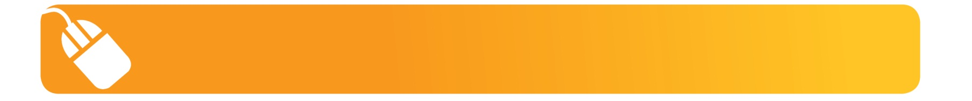
It’s here online enrolments !
To enrol, please visit www.kellysports.com.au or
fill out the enrolment form & send with a cheque or credit card details to:
Kelly Sports PO BOX 71, Moonee Vale, VIC, 3055.
Payment options available!
Do not leave enrolment forms at the school office

It’s here online enrolments !
To enrol, please visit www.kellysports.com.au or
fill out the enrolment form & send with a cheque or credit card details to:
Kelly Sports PO BOX 71, Moonee Vale, VIC, 3055.
Payment options available!
Do not leave enrolment forms at the school office

It’s here online enrolments !
To enrol, please visit www.kellysports.com.au or
fill out the enrolment form & send with a cheque or credit card details to:
Kelly Sports PO BOX 71, Moonee Vale, VIC, 3055.
Payment options available!
Do not leave enrolment forms at the school office

It’s here online enrolments !
To enrol, please visit www.kellysports.com.au or
fill out the enrolment form & send with a cheque or credit card details to:
Kelly Sports PO BOX 71, Moonee Vale, VIC, 3055.
Payment options available!
Do not leave enrolment forms at the school office

To enrol, please visit www.kellysports.com.au
or fill out the below enrolment form & send with a cheque or credit
card details to: PO BOX 71, Moonee Vale VIC 3055. Payment options available! Do not leave enrolment forms at the school office.

ONLINE ENROLMENT
www.kellysports.com.au

ENROLMENT FORM
 World Cup Soccer (After School)  Circus Skills (Lunch Time)
School: Year Level:
Name: Room No:
Address: Post Code:
Phone: Mobile/Work:
Email: Medical Conditions:

At the completion of after school clinics, does your child?  Go to after care  Get collected
Parents’ consent: I hereby authorise Kelly Sports to act on my behalf should my child require medical attention, and release
Kelly Sports North West from any liability for injury incurred by my child at Kelly Sports programmes.
Parent/Caregiver name: Signature:
Amount Paid: $ Credit card payment:  Visa  Master card
Card Number:     Expiry Date: /

