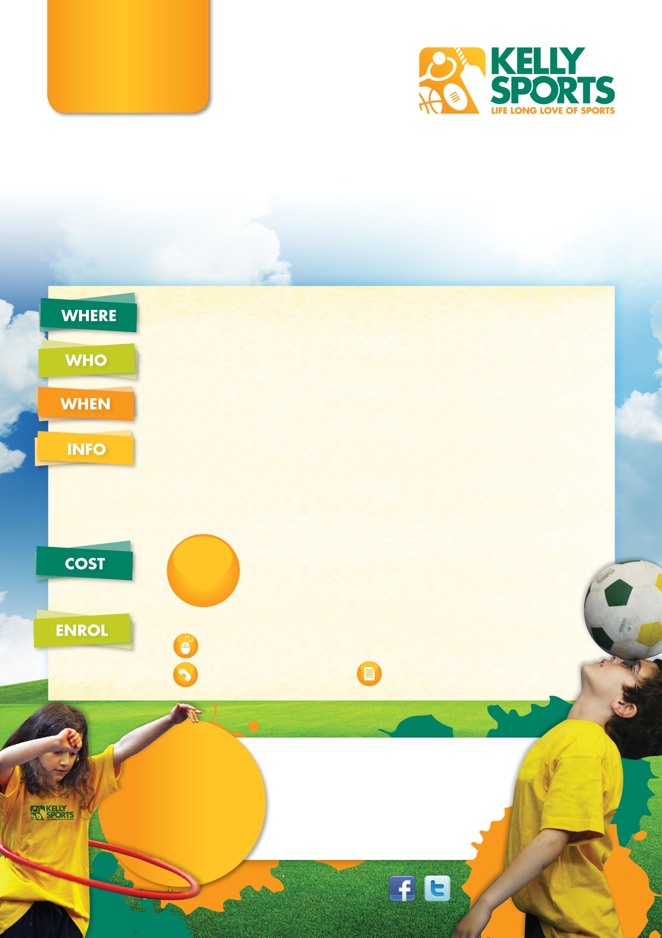

**HOLIDAY  
 PROGRAM**

**Luke Byles**

**T** (03) 9384 2204

**F** (03) 9384 2205

**E** info@kellysports.com.au

**GLEN WAVERLEY**

**SPRING IN FULL SWING!**

Sports orientated holiday program designed for children   
to emphasise fun, enjoyment and maximum participation.

**Holy Family Primary School**

**250 Stephensons Road, Mount Waverley 3149**

**Ages 4-12**

**Monday 22nd September to Friday 3rd October 2014**  
8.00am-5.00pm Daily

**Spring Holiday Fun!**

Enjoy a holiday program this spring with Kelly Sports full with lots of modified games to keep your kids entertained. These programs are designed to help kids develop basic skills such as, kicking, throwing and catching as well as having a wicked time.

Sports include, Handball, Basketball, Netball, Cricket, Hockey, Soccer, AFL,

dancing, gymnastics and many more.

* Great friendly coaches having fun and teaching all the skills.
* Special Events: Mini World Cup, AFL Grand Final and lots more.
* Daily challenges and prizes the kids will love.

**$35**

**PER DAY**

**SPECIAL DISCOUNT $150 for whole week**

**THREE WAYS TO ENROL**

Online: **www.kellysports.com.au**

Return the form: P.O Box 71 Moonee Vale

Call the franchisee

**HOW ABOUT A KELLY SPORTS BIRTHDAY PARTY!**

For more info, go to

**www.kellysports.com.au**

**LOOK OUT!**

**SEE WHAT’S**

**COMING UP**

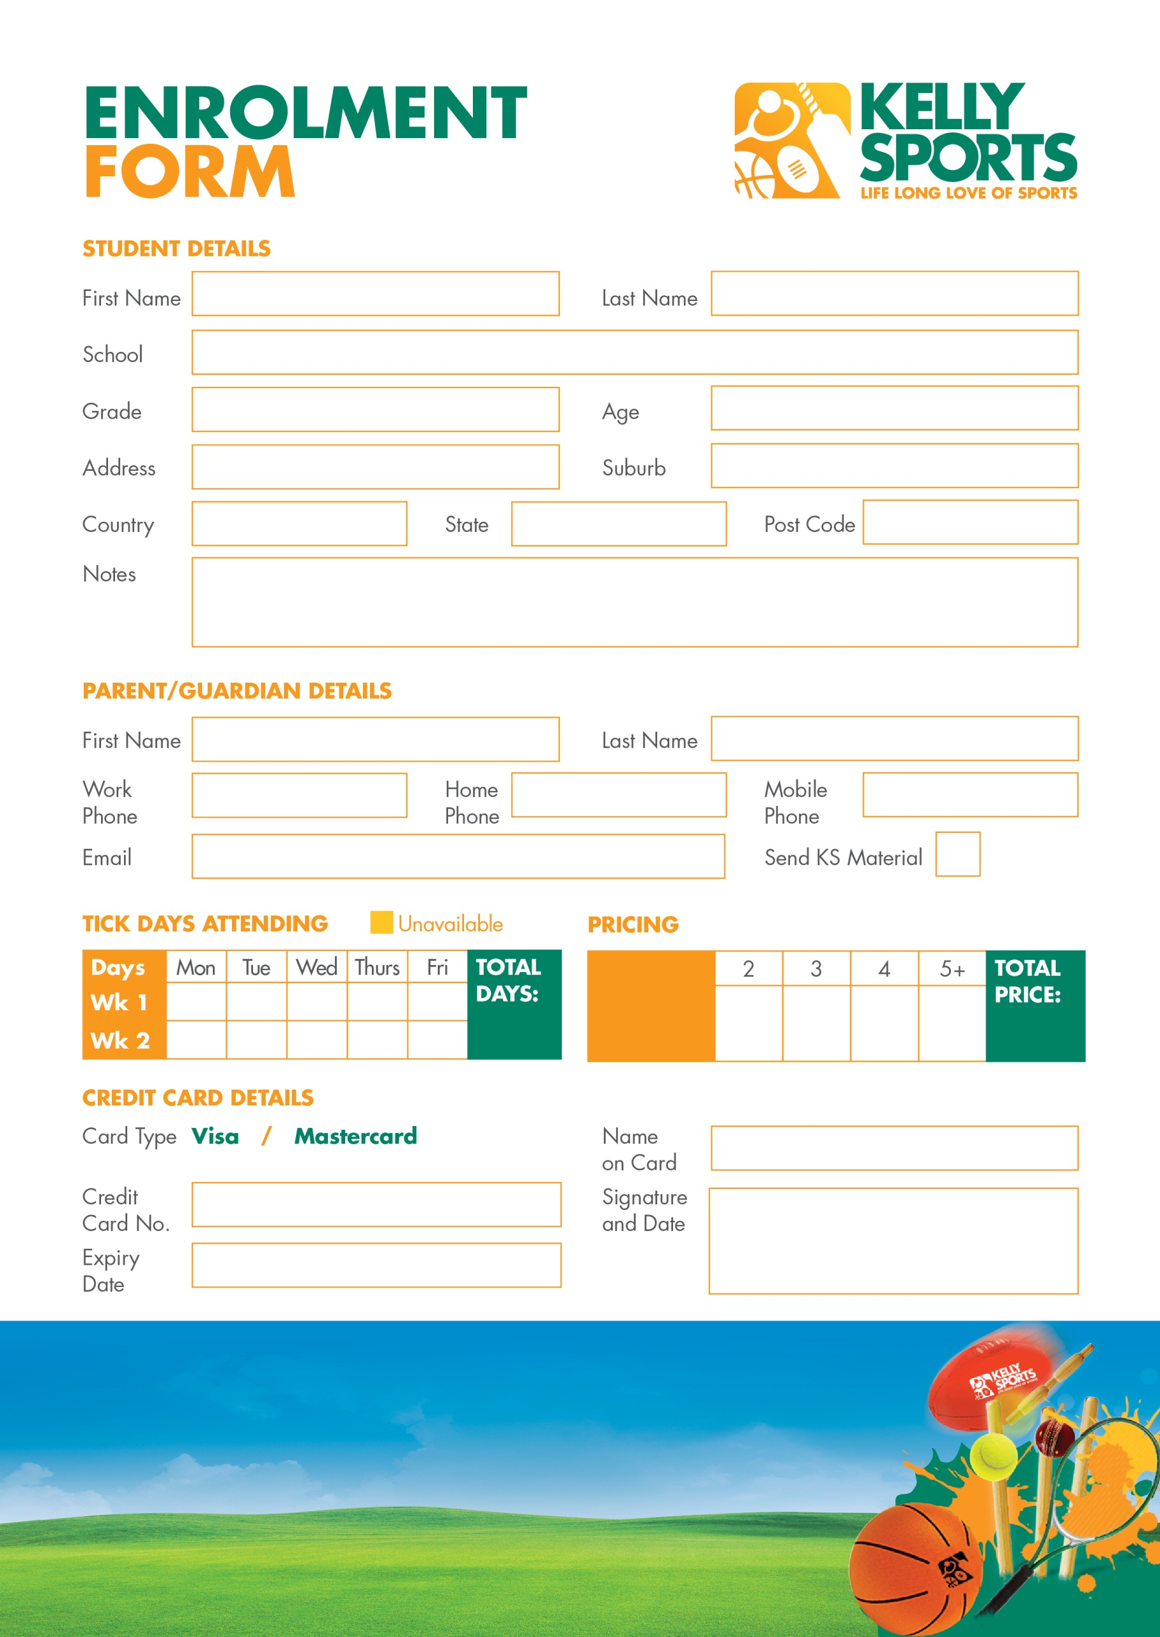

**Price**

**Per day:**

**$35**

Your children will have a blast whether they are grooving to the beats in one of our dance classes, working on their balance in gymnastics, hitting a six in cricket or giving it all a go in one of our action packed and exciting multisport programs.

**KELLY SPORTS AFTER SCHOOL / LUNCH TIME CLINICS**

**For more info, go to www.kellysports.com.au**

**$**