

P.O. Box 71, Moonee Vale 3055
T (03) 9384 2204
F (03) 9384 2205

E lukebyles@kellysports.com.au
HURRY
UP AND
ENROL!


FAIRHILLS PRIMARY SCHOOL
BRILLIANT BALL SPORTS
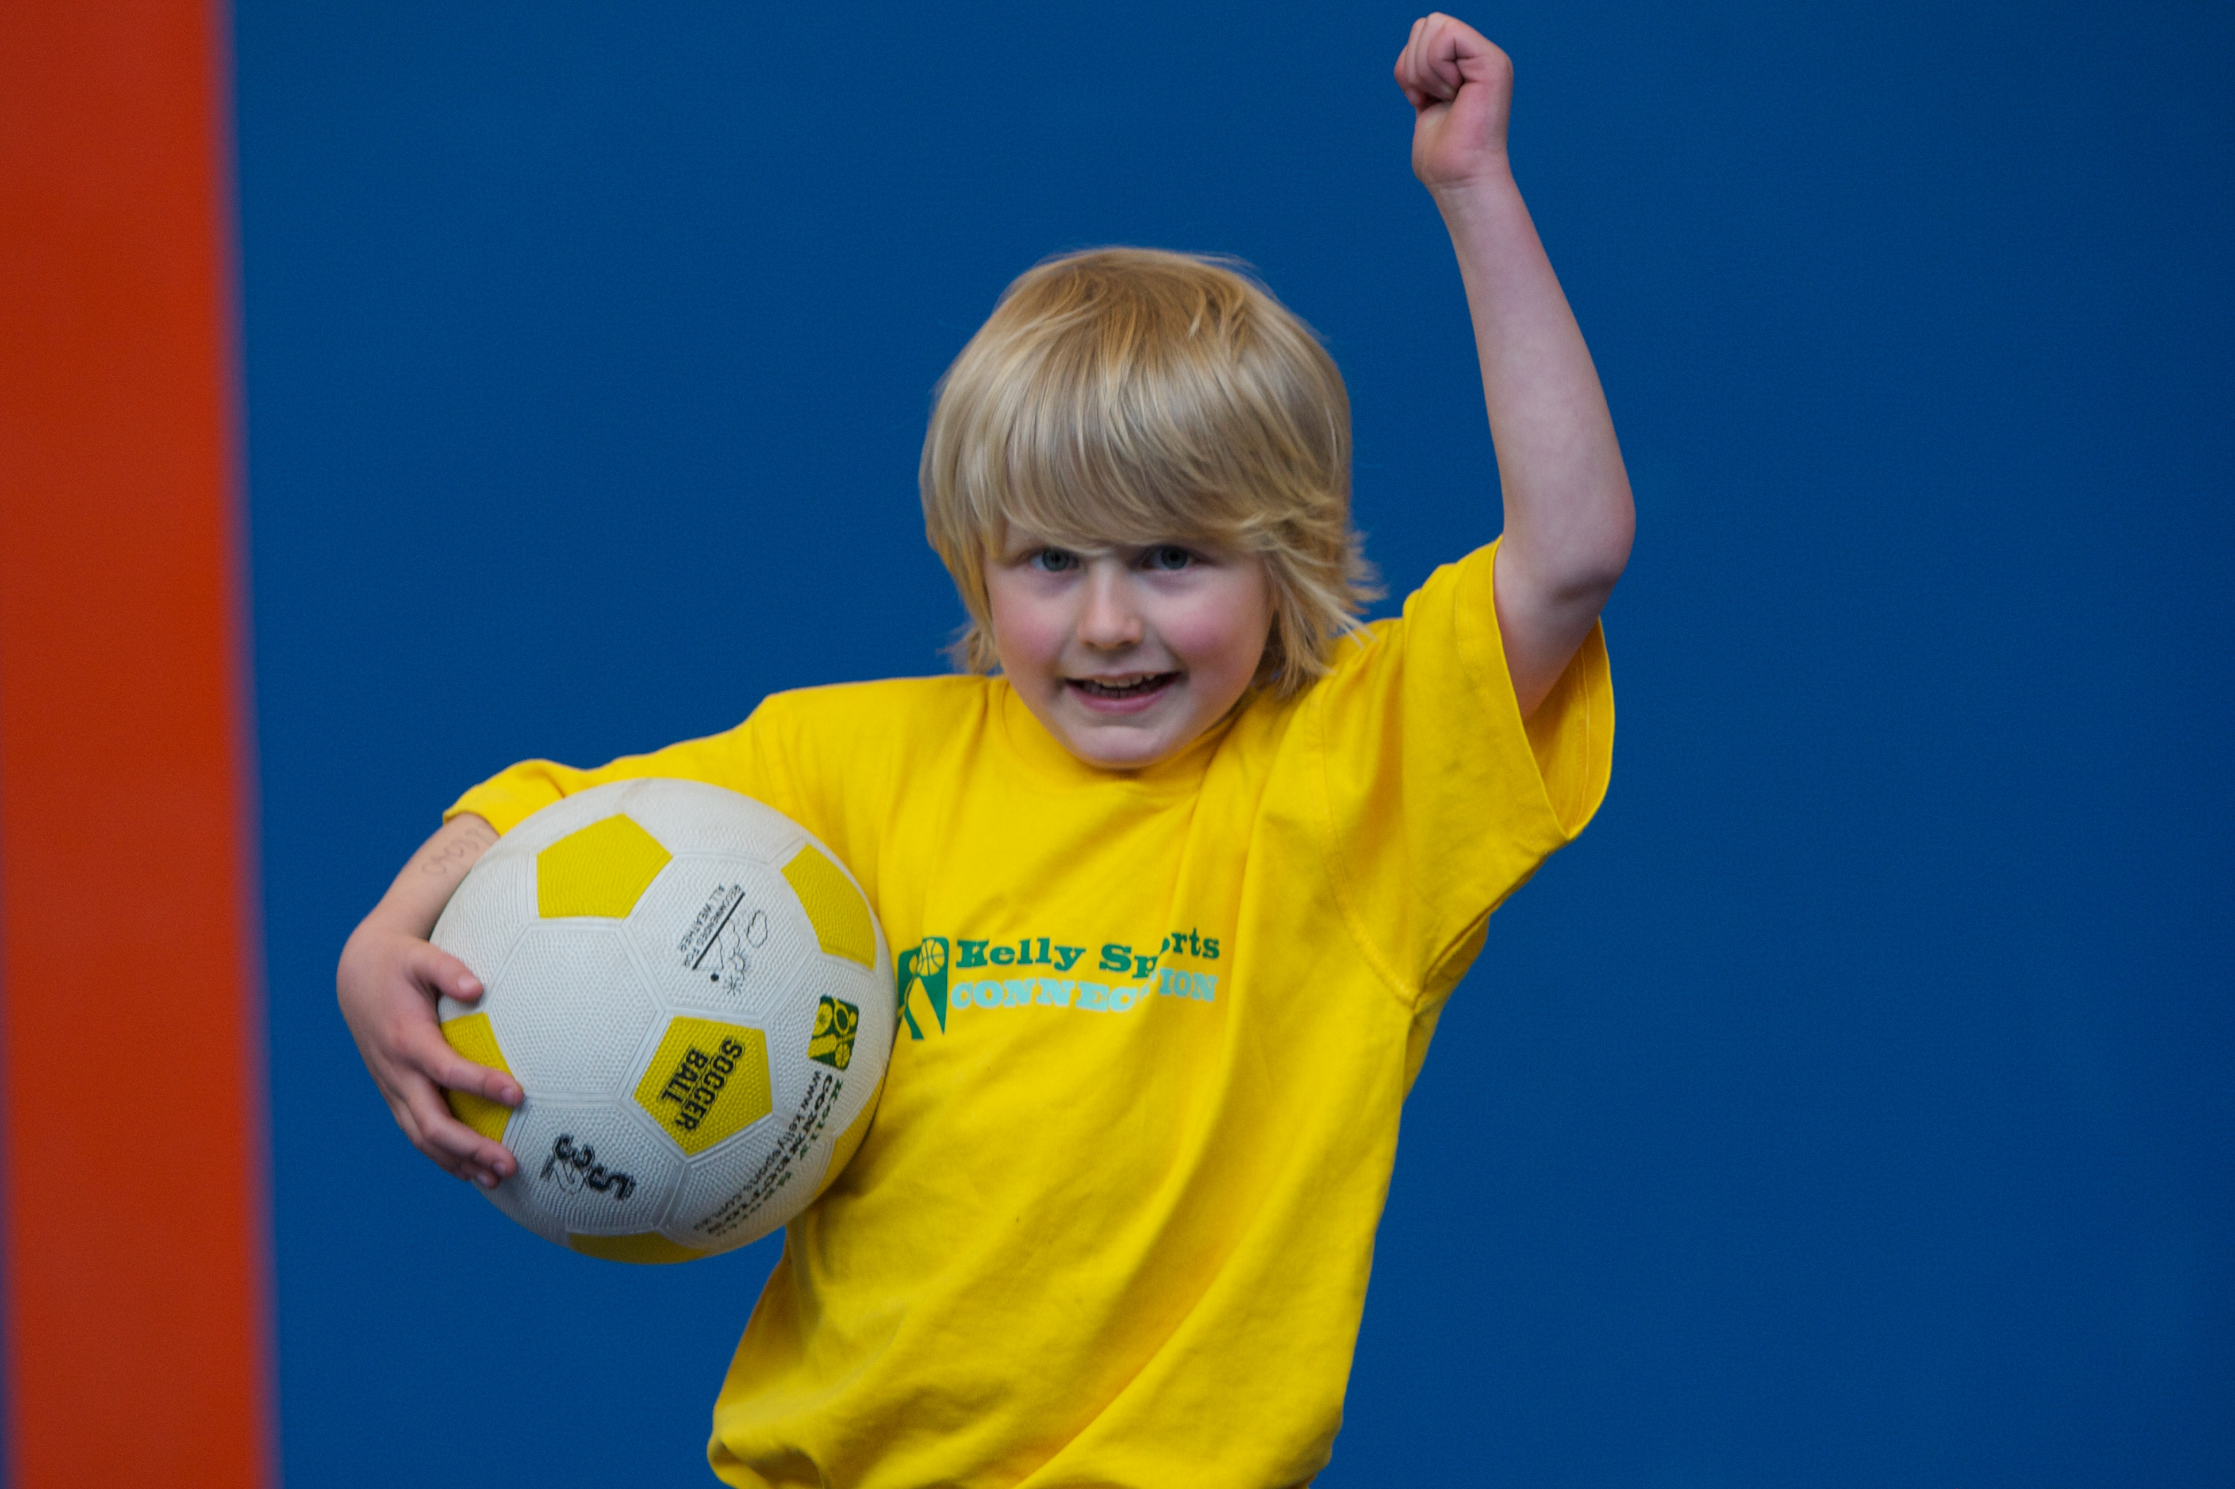
WORK UP A SWEAT! Our sports program will ensure your child will develop new skills, build coordination and awareness and increase their confidence. This 4 week program will allow your child to play Basketball and Football. Your child will learn how to play fairly and have fun all in an enjoyable environment.

WHEN: Wednesday
COMMENCING: 4/6/14
CONCLUDING: 25/6/14
TIME: 3.40pm – 4.40pm
YEAR LEVELS: P – 4


DYNAMIC DANCE

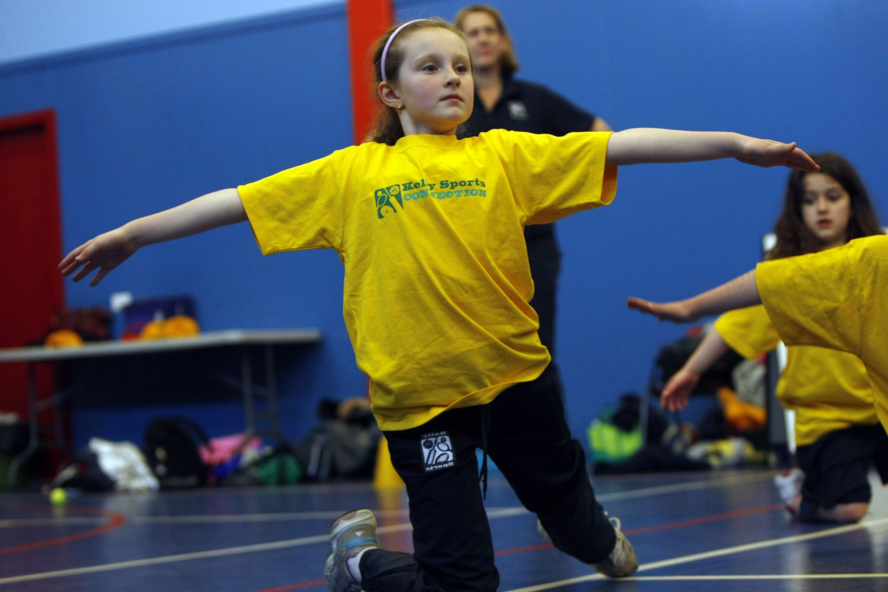
GET THOSE DANCING SHOES ON? Dance classes are a fantastic way for your child to develop their self-awareness, coordination and musicality, while socialising with other children. Dance to the latest hits while learning routines, dance steps, making friends and having loads of fun at the same time!!

WHEN: Thursday
COMMENCING: 5/6/14
CONCLUDING: 26/6/14
TIME: 3.40pm – 4.40pm
YEAR LEVELS: P – 4

COST: $40
It’s here online enrolments !
To enrol, please visit www.kellysports.com.au or
fill out the enrolment form & send with a cheque or credit card details to:
Kelly Sports PO BOX 71, Moonee Vale, VIC, 3055.
Payment options available!
Do not leave enrolment forms at the school office

VENUE: Fairhills Primary School
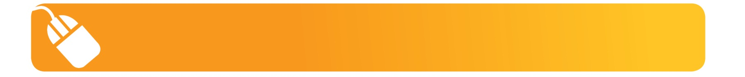
It’s here online enrolments !
To enrol, please visit www.kellysports.com.au or
fill out the enrolment form & send with a cheque or credit card details to:
Kelly Sports PO BOX 71, Moonee Vale, VIC, 3055.
Payment options available!
Do not leave enrolment forms at the school office

It’s here online enrolments !
To enrol, please visit www.kellysports.com.au or
fill out the enrolment form & send with a cheque or credit card details to:
Kelly Sports PO BOX 71, Moonee Vale, VIC, 3055.
Payment options available!
Do not leave enrolment forms at the school office

It’s here online enrolments !
To enrol, please visit www.kellysports.com.au or
fill out the enrolment form & send with a cheque or credit card details to:
Kelly Sports PO BOX 71, Moonee Vale, VIC, 3055.
Payment options available!
Do not leave enrolment forms at the school office

It’s here online enrolments !
To enrol, please visit www.kellysports.com.au or
fill out the enrolment form & send with a cheque or credit card details to:
Kelly Sports PO BOX 71, Moonee Vale, VIC, 3055.
Payment options available!
Do not leave enrolment forms at the school office

To enrol, please visit ww.kellysports.com.au
or fill out the below enrolment form & send with a cheque or credit
card details to: PO BOX 71, Moonee Vale VIC 3055. Payment options available! Do not leave enrolment forms at the school office.

ONLINE ENROLMENT
www.kellysports.com.au

ENROLMENT FORM
 Brilliant Ball Sports (After School)  Dance (After School)
School: Year Level:
Name: Room No:
Address: Post Code:
Phone: Mobile/Work:
Email: Medical Conditions:

At the completion of after school clinics, does your child?  Go to after care  Get collected
Parents’ consent: I hereby authorise Kelly Sports to act on my behalf should my child require medical attention, and release
Kelly Sports Knox-Waverley from any liability for injury incurred by my child at Kelly Sports programmes.
Parent/Caregiver name: Signature:
Amount Paid: $ Credit card payment:  Visa  Master card
Card Number:     Expiry Date: /

