  P.O. Box 71, Moonee Vale 305

**T** (03) 9384 2204

**FOLLOW US**

**ONLINE**

**F** (03) 9384 2205

**E** mitch@kellysports.com.au



**CASA BAMBINI CHILDCARE**

**FUNDEMENTAL MOTOR SKILLS PROGRAM**

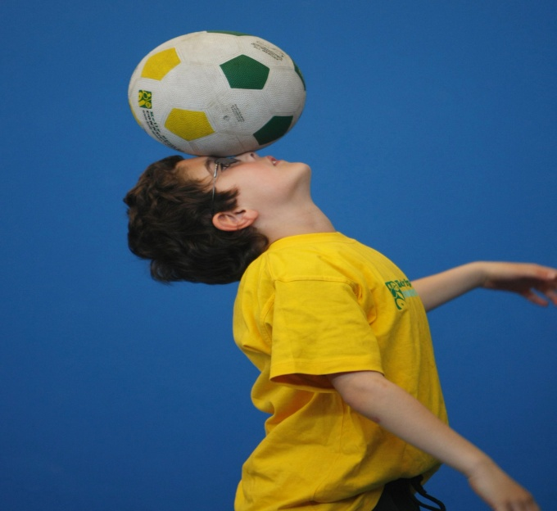

**WHEN:** Tuesday

**COMMENCING:** 11/08/15

**CONCLUDING:** 15/09/15

**TIME:** Pre Kinder 9:15am –9:45am

Kinder 9.45am – 10.15am

**COST:** $48

Kelly Sports is offering our famous fundamental motor skills program. Our 6 week program consists of fun-filled sports activities using bean bags, tennis balls, soccer balls, hula hoops, colourful ribbons, juggling scarfs and more! Our focus as always with kinder aged children is fun, excitement, maximum participation and of course fundamental motor skill development including jumping, bouncing, striking, catching, throwing, balance and hand-eye coordination.

**GET IN QUICK FOR TERM 3 AS PLACES FILLING FAST**

**$48 FOR 6 WEEK PROGRAM**

**­**

NEW IMPROVED ONLINE BOOKING SYSTEM!!!

SIMPLY GO TO [WWW.KELLYSPORTS.COM.AU](http://WWW.KELLYSPORTS.COM.AU) ENTER YOUR POST CODE AND ENROL FROM THERE. OR

FILL OUT THE BELOW ENROLMENT FOR & SEND WITH A CHEQUE OR CREDIT CARDS DETAILS TO:

**PO BOX 71, MOONEE VALE, 3055**

PAYMENT OPTIONS AVALIABLE!

**It’s here online enrolments !**

**To enrol**, please visit [www.kellysports.com.au](http://www.kellysports.com.au) or

fill out the enrolment form & **send** with a cheque or credit card details to:

Kelly Sports PO BOX 71, Moonee Vale, VIC, 3055.

Payment options available!

Do **not** leave enrolment forms at the school office

**ENROLMENT FORM**

□ **Fundamental Motor Skills**

School: Year Level:

Name: Room No:

Address: Post Code:

Phone: Mobile/Work:

Email: Medical Conditions:

At the completion of after school clinics, does your child? □ Go to after care □ Get collected

**Parents’ consent: I hereby authorise Kelly Sports to act on my behalf should my child require medical attention, and release   
Kelly Sports North West from any liability for injury incurred by my child at Kelly Sports programs.**

Parent/Caregiver name: Signature:

Amount Paid: $ Credit card payment: □ **Visa** □ **Master card**

Card Number: □□□□ □□□□ □□□□ □□□□Expiry Date: □□/□□CVV:□□□

**THINGS TO KNOW**

Kelly Sports is a Registered Child Care provider

Don’t leave forms at the School Office

Spaces are limited so please make sure you enrol online or return form to Kelly Sports.

**It’s here online enrolments !**

**To enrol**, please visit [www.kellysports.com.au](http://www.kellysports.com.au) or

fill out the enrolment form & **send** with a cheque or credit card details to:

Kelly Sports PO BOX 71, Moonee Vale, VIC, 3055.

Payment options available!

Do **not** leave enrolment forms at the school office

**It’s here online enrolments !**

**To enrol**, please visit [www.kellysports.com.au](http://www.kellysports.com.au) or

fill out the enrolment form & **send** with a cheque or credit card details to:

Kelly Sports PO BOX 71, Moonee Vale, VIC, 3055.

Payment options available!

Do **not** leave enrolment forms at the school office

**It’s here online enrolments !**

**To enrol**, please visit [www.kellysports.com.au](http://www.kellysports.com.au) or

fill out the enrolment form & **send** with a cheque or credit card details to:

Kelly Sports PO BOX 71, Moonee Vale, VIC, 3055.

Payment options available!

Do **not** leave enrolment forms at the school office