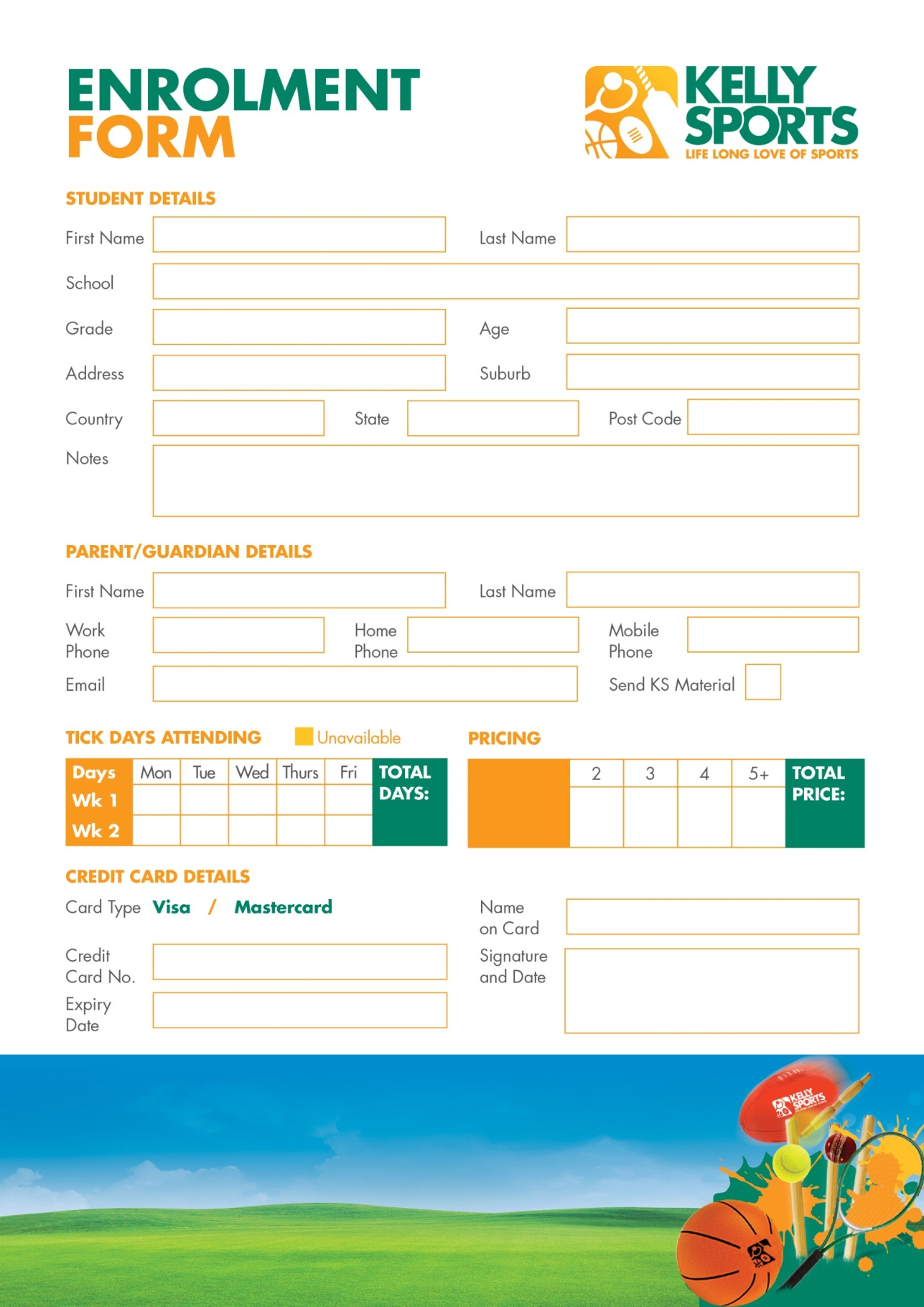

$150

$140

$105

$70

**$35**

**Price per day:**

**For more info, go to   
www.kellysports.com.au**

Your children will have a blast whether they are grooving to the beats in one of our dance classes, working on their balance in gymnastics, hitting a six in cricket or giving it all a go in one of our action packed and exciting multisport programmes.

**KELLY SPORTS AFTER SCHOOL / LUNCH TIME CLINICS**