Contact: DAVID MARCHESANI


T 0430 580 788


E david@kellysports.com.au

Like Kelly Sports Seaford on Facebook to keep up to date

ST JOACHIM’S PRIMARY SCHOOL
WILD SUMMER SPORTS

Kelly Sports is back in Term 1 Sports give them a Life Long Love of Sports for WILD SUMMER SPORTS!! Over 8 weeks your child will participate in a range of lively and energetic programs including CRICKET, SOCCER, BASKETBALL, HOCKEY & FUN GAMES. This program will not only improve key sporting skills but also increase crucial motor skills in a fun, friendly and exciting environment.

It’s here online enrolments!
To enrol, please visit www.kellysports.com.au or
fill out the enrolment form & send with a cheque or credit card details to:
Kelly Sports PO BOX 71, Moonee Vale, VIC, 3055.
Payment options available!
Do not leave enrolment forms at the school office

It’s here online enrolments !
To enrol, please visit www.kellysports.com.au or
fill out the enrolment form & send with a cheque or credit card details to:
Kelly Sports PO BOX 71, Moonee Vale, VIC, 3055.
Payment options available!
Do not leave enrolment forms at the school office

WHEN: TUESDAY
COMMENCING: 12/2/19
CONCLUDING: 02/4/19
TIME: 3.25pm – 4.25pm
YEAR LEVELS: P – GRADE 4
COST: $96.00 (inc GST)

It’s here online enrolments!
To enrol, please visit www.kellysports.com.au or
fill out the enrolment form & send with a cheque or credit card details to:
Kelly Sports PO BOX 71, Moonee Vale, VIC, 3055.
Payment options available!
Do not leave enrolment forms at the school office

It’s here online enrolments!
To enrol, please visit www.kellysports.com.au or
fill out the enrolment form & send with a cheque or credit card details to:
Kelly Sports PO BOX 71, Moonee Vale, VIC, 3055.
Payment options available!
Do not leave enrolment forms at the school office

It’s here online enrolments!
To enrol, please visit www.kellysports.com.au or
fill out the enrolment form & send with a cheque or credit card details to:
Kelly Sports PO BOX 71, Moonee Vale, VIC, 3055.
Payment options available!
Do not leave enrolment forms at the school office

BOOK
NOW
DON’T MISS OUT

GET IN QUICK FOR TERM 1 AS PLACES ARE LIMITED AND WILL FILL FAST
$96.00 FOR THE 8 WEEK PROGRAM
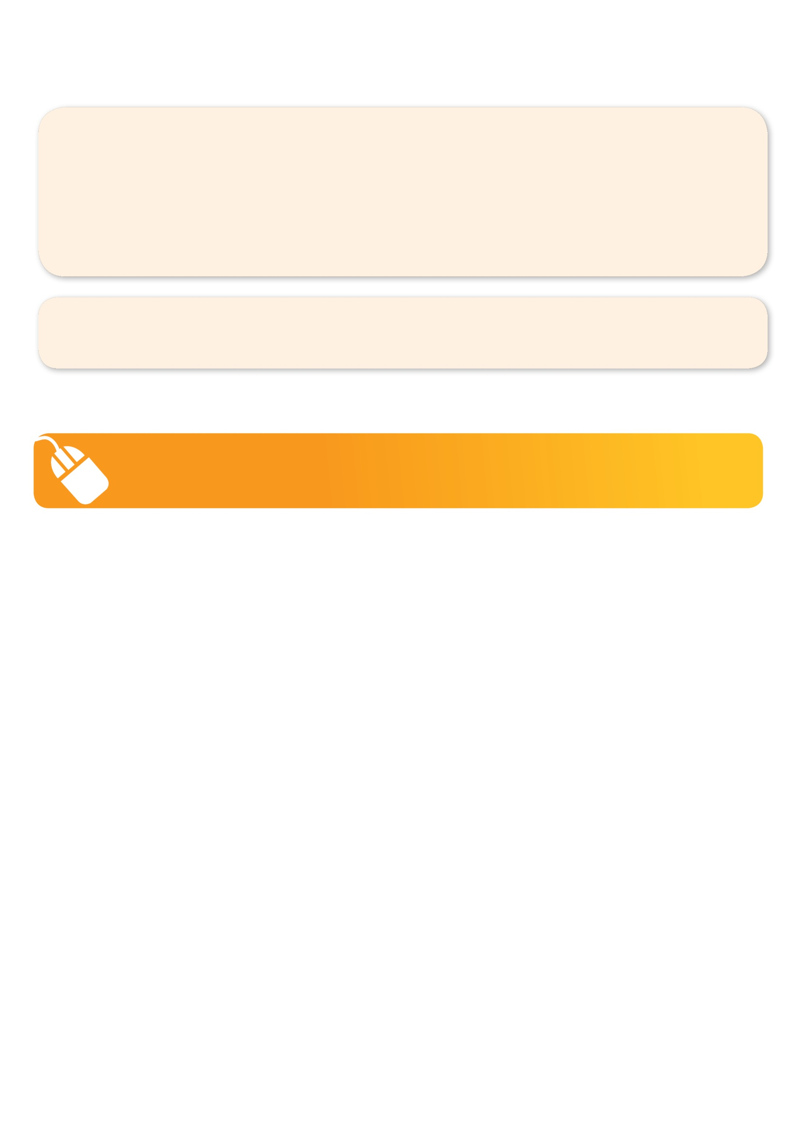
NEW IMPROVED ONLINE BOOKING SYSTEM!!!
SIMPLY GO TO WWW.KELLYSPORTS.COM.AU ENTER IN YOUR POSTCODE AND CLICK ON ST JOACHIM’S PRIMARY SCHOOL’S PROGRAM

KELLY SPORTS ALSO DOES SCHOOL HOLIDAY PROGRAMS & BIRTHDAY PARTIES.
Like our Facebook page, Kelly Sports Seaford to keep up to date with what is happening in your area.

