Contact: DAVID MARCHESANI


T 0430 580 788


E david@kellysports.com.au

RANGEBANK PRIMARY SCHOOL
INTRODUCING JAZZ FUNK DANCE!

Kelly Sports is back in Term 2 for JAZZ FUNK DANCE over 6 weeks.
Breaking, Popping and Locking!! Our specialized Dance coaches can get your child’s hips swinging, feet rocking and heads bumping to the original Jazz Funk dancing. Jazz Funk is a FUSION of styles that you child can enjoy dancing out to!!!! Sign up fast as places are limited for our program and let our coaches beat and ignite your child’s feet!

It’s here online enrolments!
To enrol, please visit www.kellysports.com.au or
fill out the enrolment form & send with a cheque or credit card details to:
Kelly Sports PO BOX 71, Moonee Vale, VIC, 3055.
Payment options available!
Do not leave enrolment forms at the school office

It’s here online enrolments !
To enrol, please visit www.kellysports.com.au or
fill out the enrolment form & send with a cheque or credit card details to:
Kelly Sports PO BOX 71, Moonee Vale, VIC, 3055.
Payment options available!
Do not leave enrolment forms at the school office

WHEN: MONDAY
COMMENCING: 20/5/19
CONCLUDING: 27/6/19
TIME: 1.30 to 2.15pm
YEAR LEVELS: P – GRADE 4
COST: $ 66.00 (inc GST)

It’s here online enrolments!
To enrol, please visit www.kellysports.com.au or
fill out the enrolment form & send with a cheque or credit card details to:
Kelly Sports PO BOX 71, Moonee Vale, VIC, 3055.
Payment options available!
Do not leave enrolment forms at the school office

It’s here online enrolments!
To enrol, please visit www.kellysports.com.au or
fill out the enrolment form & send with a cheque or credit card details to:
Kelly Sports PO BOX 71, Moonee Vale, VIC, 3055.
Payment options available!
Do not leave enrolment forms at the school office

It’s here online enrolments!
To enrol, please visit www.kellysports.com.au or
fill out the enrolment form & send with a cheque or credit card details to:
Kelly Sports PO BOX 71, Moonee Vale, VIC, 3055.
Payment options available!
Do not leave enrolment forms at the school office

BOOK NOW
Don’t Miss Out.

GET IN QUICK FOR TERM 2 AS PLACES ARE LIMITED AND WILL FILL FAST
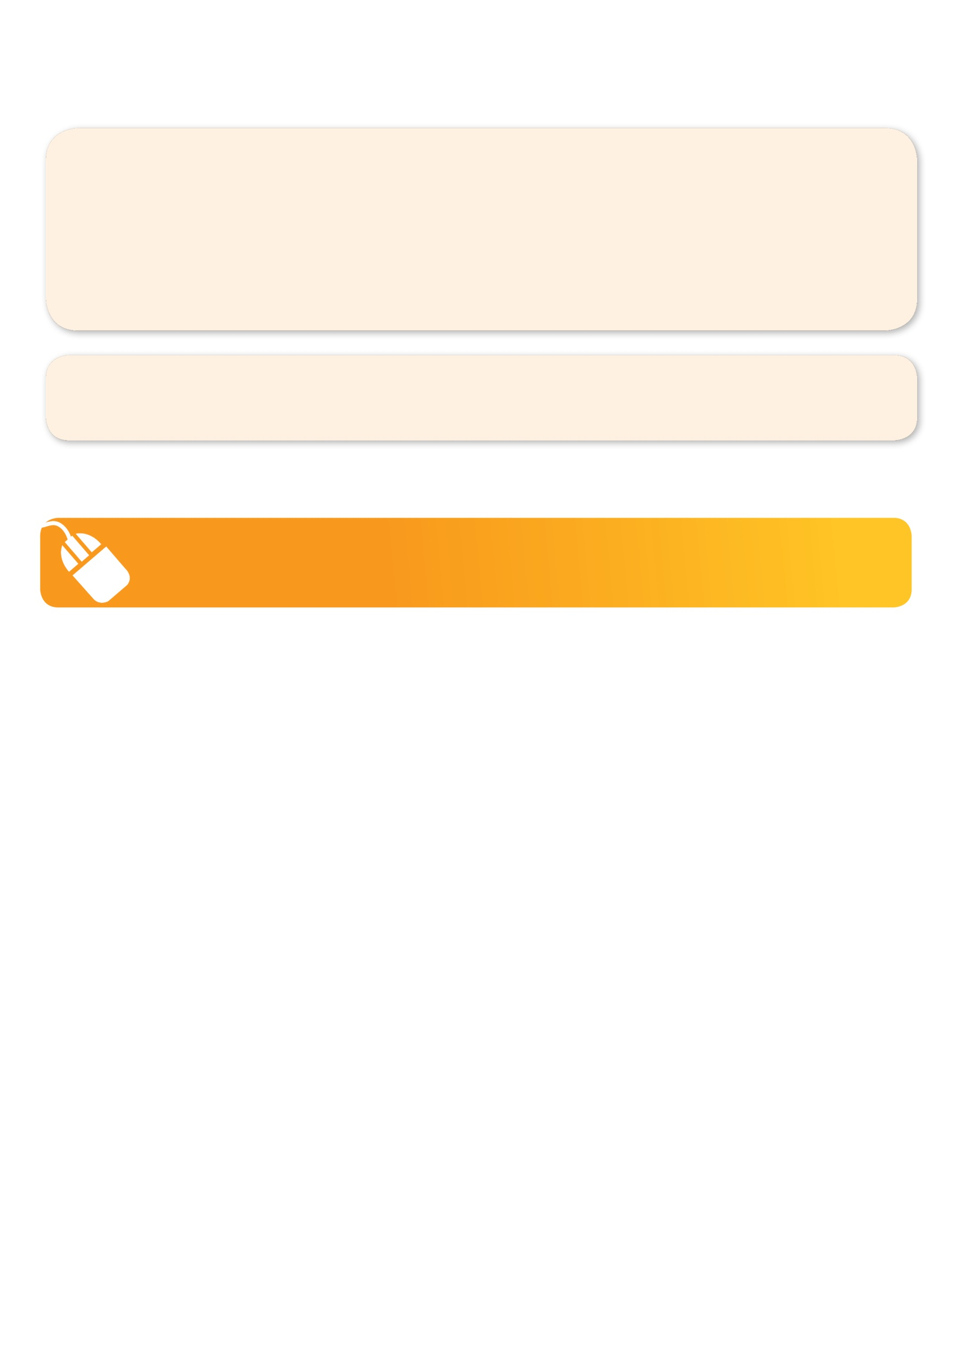
NEW IMPROVED ONLINE BOOKING SYSTEM!!!
SIMPLY GO TO WWW.KELLYSPORTS.COM.AU ENTER IN YOUR POSTCODE AND CLICK ON RANGEBANK PRIMARY SCHOOL’S PROGRAM

KELLY SPORTS ALSO DOES SCHOOL HOLIDAY PROGRAMS & BIRTHDAY PARTIES.
Like our Facebook page, Kelly Sports Seaford to keep up to date with what is happening in your area.

