PO BOX 28 Cranbourne 3977

**FOLLOW US ONLINE!**

**T** 0430 580 788

**E** [david@kellysports.com.au](mailto:david@kellysports.com.au)

Phone 0430 580 788

**ST AGATHAS PRIMARY SCHOOL**

**WILD WINTER SPORTS**

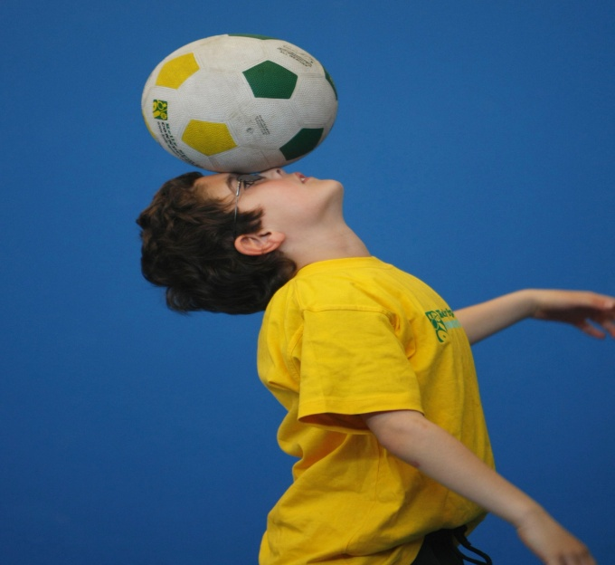

**SOCCER – BASKETBALL- AFL- HOCKEY – CRAZY GAMES** This program is a fantastic way to challenge and improve your child’s motor and coordination skills. Our experienced coaches aim to develop and enhance the wide range of sporting skills of your child, including catching, kicking & throwing. While also improving strength, flexibility, hand-eye co-ordination, spatial awareness, co-operative skills and teamwork, all within a FUN and very SAFE environment.

**WHEN:** MONDAY

**COMMENCING:** 23/7/18

**CONCLUDING:** 17/9/18

**TIME:** 3.40pm – 4.40pm

**YEAR LEVELS:** P – 4

**COST:** $99(Including GST)



**GROOVY JAZZ DANCE**

Breaking, Popping and Locking!! Our specialized Dance coaches can get your child’s hips swinging, feet rocking and heads bumping to the original street dancing. Street dance is a FUSION of styles that you child can enjoy dancing out to!!!! Sign up fast as places are limited for our program and let our coaches beat, ignite your child’s feet!

**WHEN:** Tuesday

**COMMENCING:** 24/7/18

**CONCLUDING:** 18/9/18

**TIME:** 1.15pm-2.00pm

**YEAR LEVELS:** P – 4

**COST:** $99 (Including GST)



**GET IN QUICK FOR TERM 3 AS PLACES FILLING FAST**

**It’s here online enrolments !**

**To enrol**, please visit [www.kellysports.com.au](http://www.kellysports.com.au) or

fill out the enrolment form & **send** with a cheque or credit card details to:

Kelly Sports PO BOX 71, Moonee Vale, VIC, 3055.

Payment options available!

Do **not** leave enrolment forms at the school office

**$99.00 FOR 9 WEEK PROGRAM**

**­**

SIGN UP FAST TO HAVE FUN WHILE LEARNING NEW SKILLS!

SIMPLY GO TO [WWW.KELLYSPORTS.COM.AU](http://WWW.KELLYSPORTS.COM.AU) ENTER YOUR POST CODE AND ENROL FROM THERE. OR

FILL OUT THE BELOW ENROLMENT FORM & SEND WITH A CHEQUE OR CREDIT CARDS DETAILS TO:

**P.O BOX 28 CRANBOURNE 3977**

PAYMENT OPTIONS AVAILABLE!

**It’s here online enrolments !**

**To enrol**, please visit [www.kellysports.com.au](http://www.kellysports.com.au) or

fill out the enrolment form & **send** with a cheque or credit card details to:

Kelly Sports PO BOX 71, Moonee Vale, VIC, 3055.

Payment options available!

Do **not** leave enrolment forms at the school office



**ENROLMENT FORM**

□**WI Winter Sports** □ **Groovy Jazz**

School: Year Level:

Name: Room No:

Address: Post Code:

Phone: Mobile/Work:

Email: Medical Conditions:

At the completion of after school clinics, does your child? □ Go to after care □ Get collected

**Parents’ consent: I hereby authorise Kelly Sports to act on my behalf should my child require medical attention, and release   
Kelly Sports Western Region from any liability for injury incurred by my child at Kelly Sports programs.**

Parent/Caregiver name: Signature:

Amount Paid: $ Credit card payment: □ **Visa** □ **Master card**

Card Number: □□□□ □□□□ □□□□ □□□□Expiry Date: □□/□□CVV:□□□

**THINGS TO KNOW**

Don’t leave forms at the School Office

Spaces are limited so please make sure you enrol online or return form to Kelly Sports.

**It’s here online enrolments !**

**To enrol**, please visit [www.kellysports.com.au](http://www.kellysports.com.au) or

fill out the enrolment form & **send** with a cheque or credit card details to:

Kelly Sports PO BOX 71, Moonee Vale, VIC, 3055.

Payment options available!

Do **not** leave enrolment forms at the school office

**It’s here online enrolments !**

**To enrol**, please visit [www.kellysports.com.au](http://www.kellysports.com.au) or

fill out the enrolment form & **send** with a cheque or credit card details to:

Kelly Sports PO BOX 71, Moonee Vale, VIC, 3055.

Payment options available!

Do **not** leave enrolment forms at the school office

**It’s here online enrolments !**

**To enrol**, please visit [www.kellysports.com.au](http://www.kellysports.com.au) or

fill out the enrolment form & **send** with a cheque or credit card details to:

Kelly Sports PO BOX 71, Moonee Vale, VIC, 3055.

Payment options available!

Do **not** leave enrolment forms at the school office