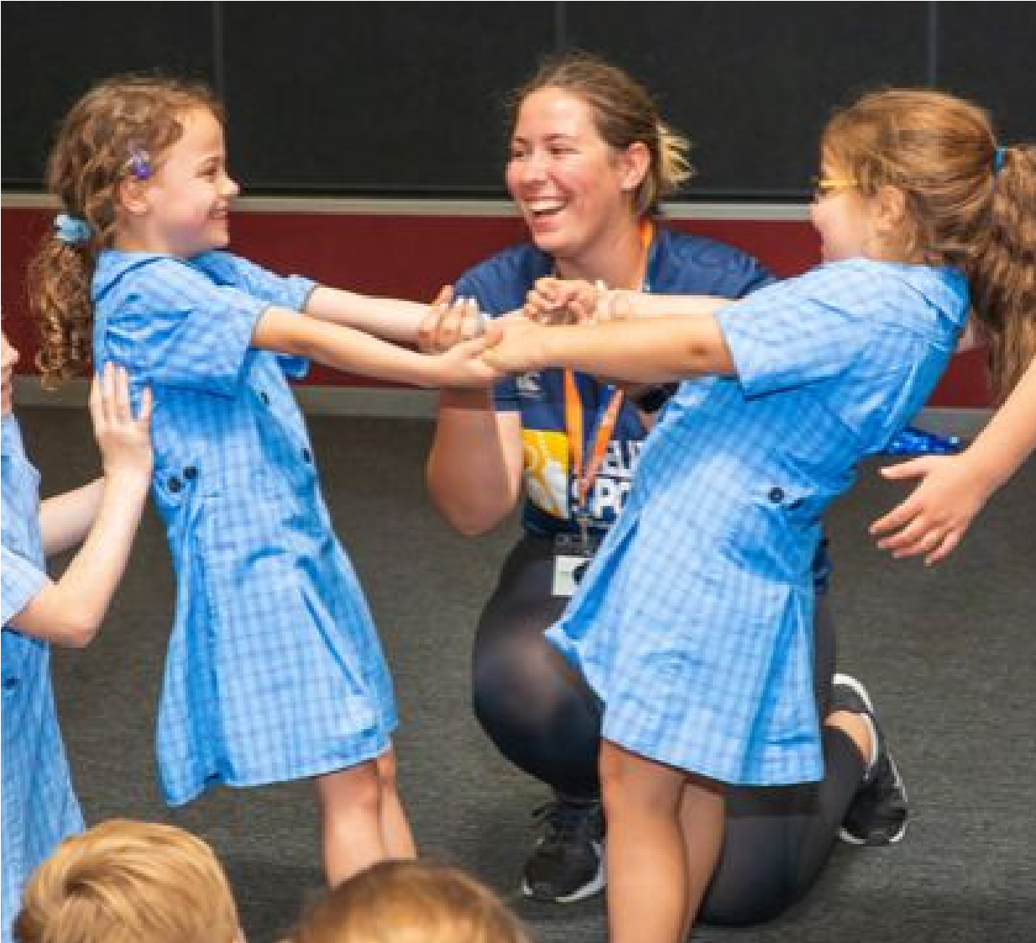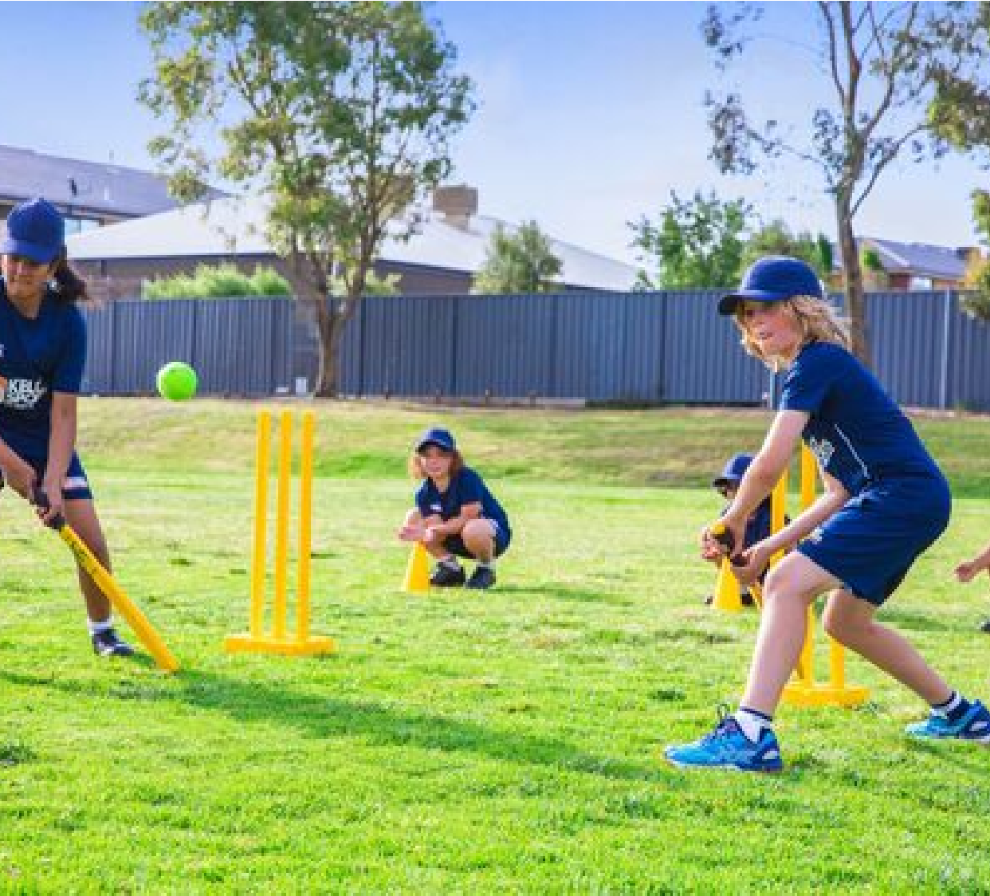

DANCE

PROGRAMME

TERM 4 2019



Have heaps of fun in the sun with your friends

while playing a range of dynamic and active

sports over the term.

It's the end of the year and it's time to cheer!

Combining Hip Hop and Cheerleading to

create a new and fresh routine in our high

intensity, excitement-filled programme.

MULTI-SPORTS

PROGRAMME

TERM 4 2019



MULTI-SPORTS

PROGRAMME

TERM 4 2019 INFORMATION

PRICES FROM $108.00 TO $120.00

St Agathas P.S – Mon, 3.40 -4.40pm. $108.00

Lyndhurst P.S – Tues, 3.40 - 4.40pm $108.00

St Joachims P.S – Tues, 3.25- 4.25pm $108.00

Rangebank P.S – Wed, 3.40- 4.40pm $120.00

For Prep – Year 4 students.

This term we will focus on the following sports:

Cricket



Programmes run weekly on one day a week for one hour.

Basketball



Soccer



Hockey



T- Ball



Crazy Games



This weekly programme gives children skills and confidence in a fun

and enjoyable environment. It also encourages their enthusiasm for

sport and the life skills that such involvement brings – giving them

confidence to join sports clubs and teams in the future.

BOOK EARLY & SAVE

Book before the 11th Oct to recieve $12.00 Discount.

David Marchesani

0430 580 788

david@kellysports.com.au

kellysports.com.au.

#KellySports Seaford

DANCE

PROGRAMME

TERM 4 2019 INFORMATION

PRICES FROM $99.00 TO $110.00

Rangebank P.S – Mon, 1.30 - 2.15pm $99.00

St Agathas P.S – Tues, 1.15-2.00pm $99.00

Lyndhurst P.S – Weds, 12.50-1.40pm $110.00

St Joachims P.S – Frid, 1.40-2.10pm $99.00

For Prep – Year 4 students.

This term we will focus on the following skills:

Hip Hop Dance



Programmes run weekly on one day a week for one hour.

Co-ordination



Dance Skills



This weekly programme gives children skills and confidence in a fun

and enjoyable environment. It also encourages their enthusiasm and

participation and the life skills that such involvement brings – giving

them increased confidence in the future.

BOOK EARLY & SAVE

Book before the 11th Oct to recieve $11.00

Discount.