Contact: DAVID MARCHESANI


T 0430 580 788


E david@kellysports.com.au

BARTON PRIMARY SCHOOL
WILD SPRING SPORTS

Kelly Sports is back in Term 4 for WILD SPRING SPORTS!! Over 10 weeks your child will participate in a range of lively and energetic programs including CRICKET, SOCCER, BASKETBALL, HOCKEY & FUN GAMES. This program will not only improve key sporting skills but also increase crucial motor skills in a fun, friendly and exciting environment. Enrol them now and let Kelly Sports give them a Life Long Love of Sports.

It’s here online enrolments!
To enrol, please visit www.kellysports.com.au or
fill out the enrolment form & send with a cheque or credit card details to:
Kelly Sports PO BOX 71, Moonee Vale, VIC, 3055.
Payment options available!
Do not leave enrolment forms at the school office

It’s here online enrolments !
To enrol, please visit www.kellysports.com.au or
fill out the enrolment form & send with a cheque or credit card details to:
Kelly Sports PO BOX 71, Moonee Vale, VIC, 3055.
Payment options available!
Do not leave enrolment forms at the school office

WHEN: THURSDAY
COMMENCING: 18/9/18
CONCLUDING: 20/12/18
TIME: 3.25pm – 4.25pm
YEAR LEVELS: P – GRADE 4
COST: $110.00 (inc GST)

It’s here online enrolments!
To enrol, please visit www.kellysports.com.au or
fill out the enrolment form & send with a cheque or credit card details to:
Kelly Sports PO BOX 71, Moonee Vale, VIC, 3055.
Payment options available!
Do not leave enrolment forms at the school office

It’s here online enrolments!
To enrol, please visit www.kellysports.com.au or
fill out the enrolment form & send with a cheque or credit card details to:
Kelly Sports PO BOX 71, Moonee Vale, VIC, 3055.
Payment options available!
Do not leave enrolment forms at the school office

It’s here online enrolments!
To enrol, please visit www.kellysports.com.au or
fill out the enrolment form & send with a cheque or credit card details to:
Kelly Sports PO BOX 71, Moonee Vale, VIC, 3055.
Payment options available!
Do not leave enrolment forms at the school office

BOOK
NOW
DON’T MISS OUT

GET IN QUICK FOR TERM 4 AS PLACES ARE LIMITED AND WILL FILL FAST
$110 FOR THE 10 WEEK PROGRAM
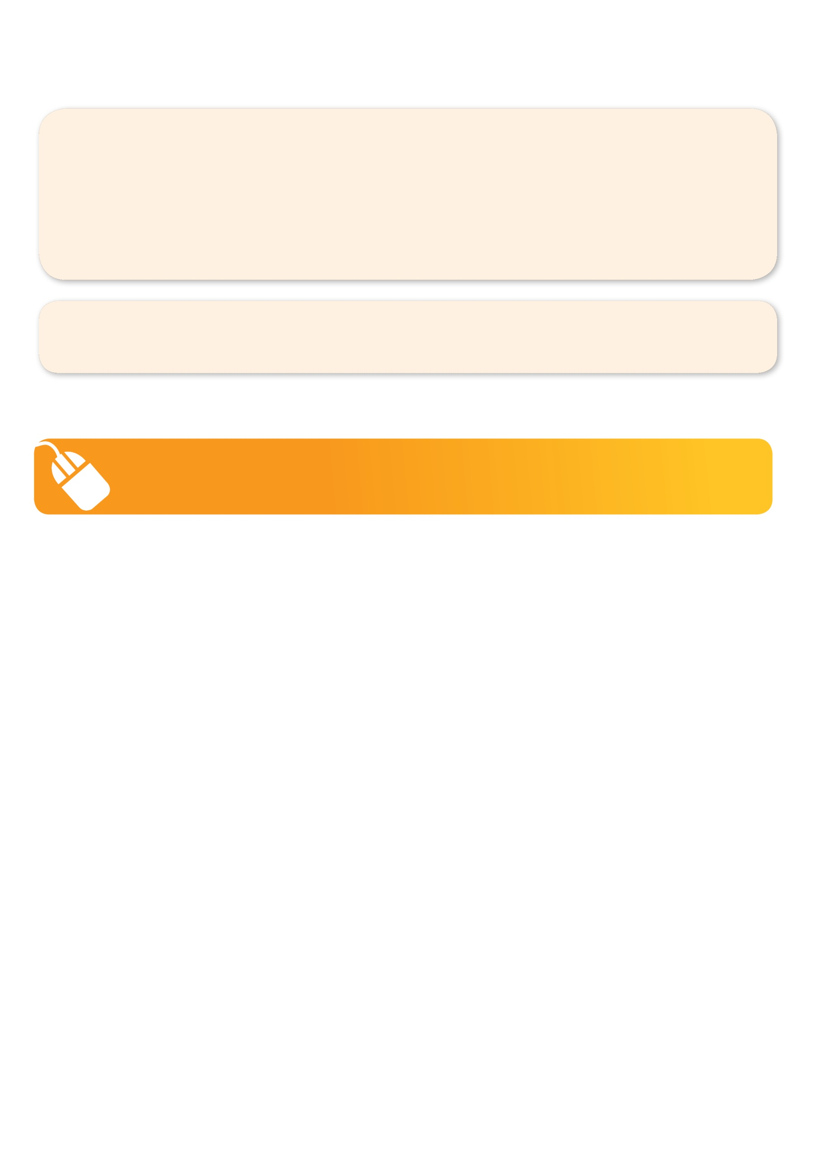
NEW IMPROVED ONLINE BOOKING SYSTEM!!!
SIMPLY GO TO WWW.KELLYSPORTS.COM.AU ENTER IN YOUR POSTCODE AND CLICK ON BARTON PRIMARY SCHOOL’S PROGRAM

KELLY SPORTS ALSO DOES SCHOOL HOLIDAY PROGRAMS & BIRTHDAY PARTIES.
Like our Facebook page, Kelly Sports Seaford to keep up to date with what is happening in your area.

