Contact: DAVID MARCHESANI


T 0430 580 788


E david@kellysports.com.au

TULLIALLAN PRIMARY SCHOOL
WILD WINTER SPORTS

Kelly Sports is back in Term 3 for WICKED WINTER SPORTS!! Over 9 weeks your child will participate in a range of lively and energetic programs including AFL, SOCCER, BASKETBALL, HOCKEY & FUN GAMES. This program will not only improve key sporting skills but also increase crucial motor skills in a fun, friendly and exciting environment. Enrol them now and let Kelly Sports give them a Life Long Love of Sports.

It’s here online enrolments!
To enrol, please visit www.kellysports.com.au or
fill out the enrolment form & send with a cheque or credit card details to:
Kelly Sports PO BOX 71, Moonee Vale, VIC, 3055.
Payment options available!
Do not leave enrolment forms at the school office

It’s here online enrolments !
To enrol, please visit www.kellysports.com.au or
fill out the enrolment form & send with a cheque or credit card details to:
Kelly Sports PO BOX 71, Moonee Vale, VIC, 3055.
Payment options available!
Do not leave enrolment forms at the school office

WHEN: WEDNESDAY
COMMENCING: 25/7/18
CONCLUDING: 19/9/18
TIME: 3.30pm – 4.30pm
YEAR LEVELS: P – GRADE 4
COST: $ 99.00 (inc GST)

It’s here online enrolments!
To enrol, please visit www.kellysports.com.au or
fill out the enrolment form & send with a cheque or credit card details to:
Kelly Sports PO BOX 71, Moonee Vale, VIC, 3055.
Payment options available!
Do not leave enrolment forms at the school office

It’s here online enrolments!
To enrol, please visit www.kellysports.com.au or
fill out the enrolment form & send with a cheque or credit card details to:
Kelly Sports PO BOX 71, Moonee Vale, VIC, 3055.
Payment options available!
Do not leave enrolment forms at the school office

It’s here online enrolments!
To enrol, please visit www.kellysports.com.au or
fill out the enrolment form & send with a cheque or credit card details to:
Kelly Sports PO BOX 71, Moonee Vale, VIC, 3055.
Payment options available!
Do not leave enrolment forms at the school office

Enrol before 13/7/18 and get the 9 weeks for the price of 8 that’s $88 for the 9! 979weeks.

GET IN QUICK FOR TERM 3 AS PLACES ARE LIMITED AND WILL FILL FAST
$99 FOR THE 9 WEEK PROGRAM
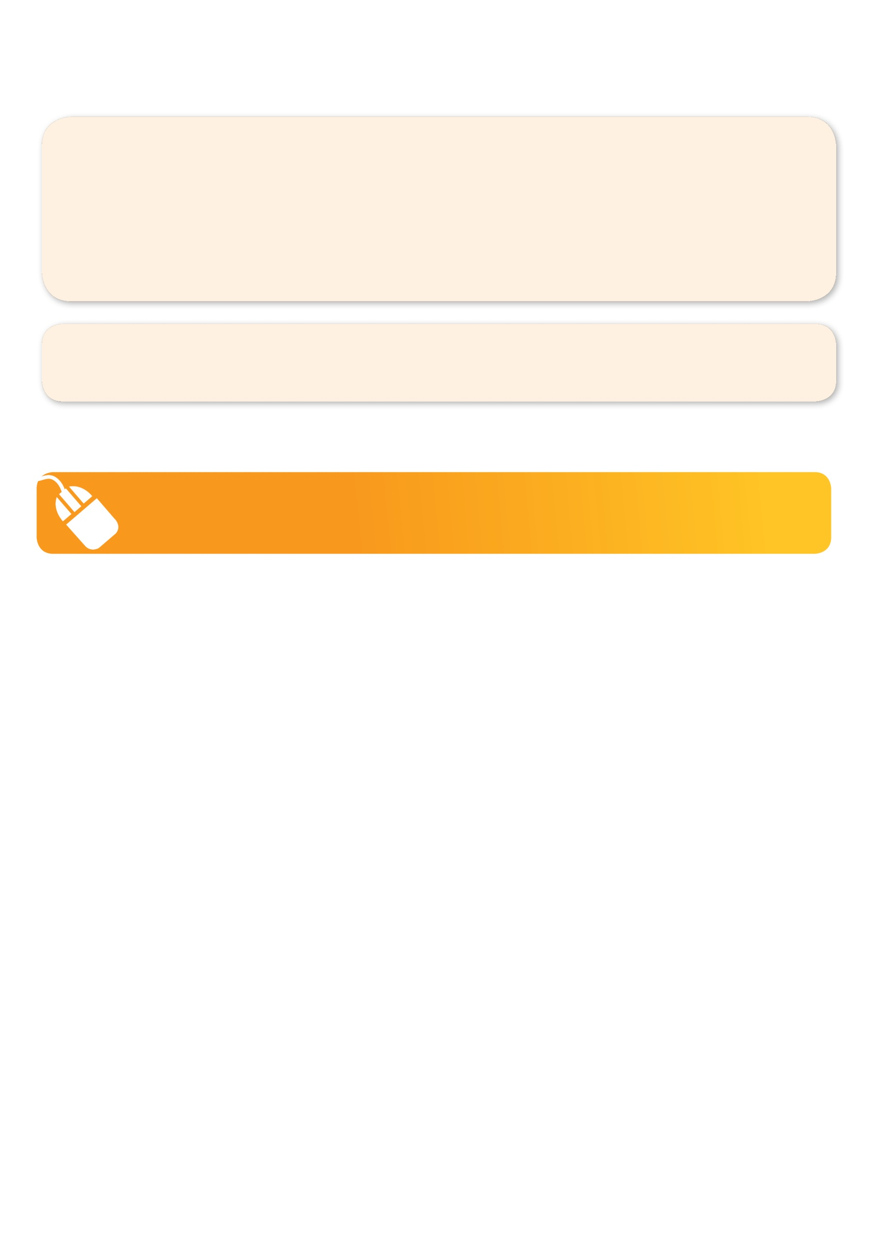
NEW IMPROVED ONLINE BOOKING SYSTEM!!!
SIMPLY GO TO WWW.KELLYSPORTS.COM.AU ENTER IN YOUR POSTCODE AND CLICK ON TULLIALLAN PRIMARY SCHOOL’S PROGRAM

KELLY SPORTS ALSO DOES SCHOOL HOLIDAY PROGRAMS & BIRTHDAY PARTIES.
Like our Facebook page, Kelly Sports Seaford to keep up to date with what is happening in your area.

